**WebR Installation and Configuration Guide**

**V 6.2**

**PG&E ED AM/GIS**

July 28 2014

Prepared By: IBM

|  |
| --- |
| **Table of Contents** |

GIS Server Pre-Requisite Installs 5

Shut off firewall or Open Ports – GIS Server/Web Servers 6

Installation of ArcGIS Server 10.1 11

Configure ArcGIS Server Manager on the GIS Server 17

Installation of ArcFM Server 10.1 21

Install ArcGIS Server Styles and True Type Fonts 26

Web Server Pre-Requisite Installs 28

Shut off Firewall or Open ArcGIS Server Ports 32

Install ArcGIS 10.1 Web Adaptor 33

Install PG&E Silverlight – ED Viewer on All Web Servers 39

**Service Publishing Machine Pre-Requisite Installs** 42

**Create Database Connections for Publishing** 43

Create an Administrative Connection to the ArcGIS Site 47

Register Data Stores with the ArcGIS Site 50

**Create the WIP and Redline Data Stores** 53

Feature Edit Templates - Set Up Feature Services 63

Publish Redline Feature Service 70

Publish WIP Redline – Edit Feature Service 74

Publish WIP Redline – Search Service 77

Publish Publication Feature Service 80

Publish Printing Tools Service 83

Registering the print templates folder with ArcGIS Server 83

Creating a Print Template in ArcMap 85

Creating/Updating the ArcGIS Server Print Service 89

Creating/Updating the ArcGIS Server ExtractSend Service 97

Deploy Modified SendEmailWithZip.py script to Print Servers 103

Convert ArcFM Stored Displays to MXDs 106

Create a Landbase MXD with appropriate layers 109

Create a Geometry Service on the GIS Server 110

Publish ArcGIS/ArcFM ED Map Services 111

Configure Resources with PG&E Silverlight ED Viewer 116

Configure the Templates Configuration File 135

|  |  |  |  |
| --- | --- | --- | --- |
| Revision History | | | |
| Document # | Date | Author | Summary of Changes |
| 1.0 | May 2, 2013 | Ben Dwinal | Initial draft |
| 3.0 | May 9 2013 | Lance Goens | Updates from install of v1.2 |
| 4.0 | July 5 2013 | John Reed | Updates for coded domain limit increase |
| 5.0 | July 19 2013 | Betsy Rush | Formatting updates. Updates from July 11 test install for EDVIEWER v1.5 |
| 6.0 | May 6 2014 | Philip Penn | EDVIEWER v2.0.0 |
| 6.2 | July 28 2014 | Philip Penn | EDVIEWER v3.0.0 |

**GIS Server Machine Installs**

**(Installation steps for all GIS Servers)**

# GIS Server Pre-Requisite Installs

**1) OS = Windows Server 2008 R2**

**2) Check that the Microsoft.Net Framework 4 Client Profile is installed.**

- If not installed, download and install.

<http://www.microsoft.com/en-us/download/details.aspx?id=17113>

**3) Check that the Microsoft.Net Framework 4 Extended is installed.**

- If not installed, download and install.

<http://www.microsoft.com/en-us/download/details.aspx?id=17718>

**4) 64-bit Oracle Client is installed and configured properly with a valid TNSNames and SQLNET.**

* Valid tnsnames.ora and sqlnet.ora files in oracle home\Netowrk\admin directory.
  + TNSNAMES file has valid entries for the following Data sources:

EDGISA1T.world =

  (DESCRIPTION =

    (ADDRESS_LIST =

      (ADDRESS = (PROTOCOL = TCP)(HOST = edgisdbtst01.comp.pge.com)(PORT = 1521))

    )

    (CONNECT_DATA =

      (SERVICE_NAME = EDGISA1T)

    )

  )

EDGISP2T.WORLD =

  (DESCRIPTION =

    (ADDRESS_LIST =

      (ADDRESS = (PROTOCOL = TCP)(HOST = edgiswebdb01.comp.pge.com)(PORT = 1521))

    )

    (CONNECT_DATA =

      (SERVICE_NAME = EDGISP2T)

    )

  )

EDGISW1T, EDGISW1T.WORLD =

  (DESCRIPTION =

    (ADDRESS_LIST =

      (ADDRESS = (PROTOCOL = TCP)(HOST = edgisdboraqa02.comp.pge.com)(PORT = 1521))

    )

    (CONNECT_DATA =

      (SERVICE_NAME = EDGISW1T)

    )

  )

# Shut off firewall or Open Ports – GIS Server/Web Servers

***\*\*\*\*\*\*\*\* (Step is only needed for Multiple Machine Deployments)***

***Shutting of Windows Firewall (Option #1)***

1. On each GIS and Web Server, Open Server Manager.

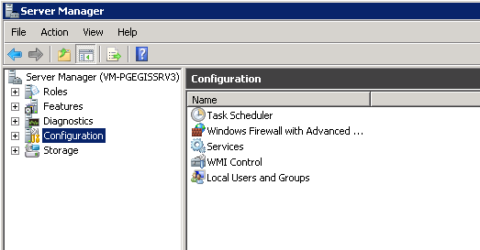

1. Expand the Configuration Node.

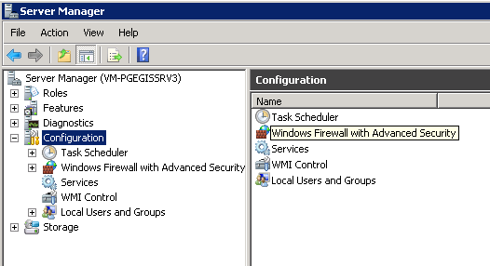

1. Click on the “Windows Firewall” node.

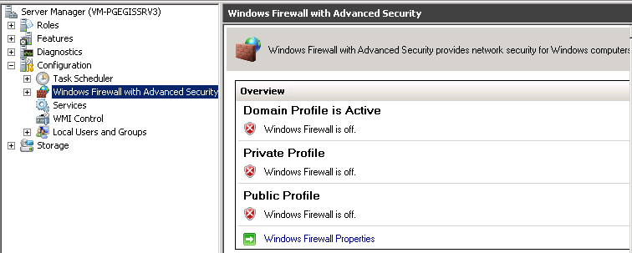

1. Use the windows Firewall Properties dialog to shut off the firewalls, if any are enabled, on the Server.

***Opening ArcGIS Server Specific Ports (Option #2)***

1. On the GIS Server, Open Server Manager.
2. Expand the “Configuration” node.
3. Click on the “Windows Firewall” node to expand it.

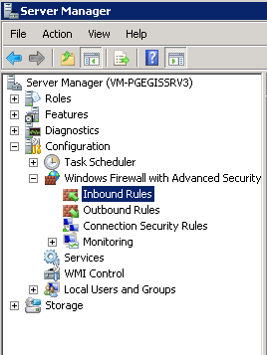

1. Right Click on “Inbound Rules” and select “New Rule” from the context menu.

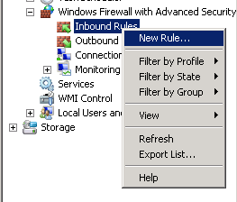

1. On the New Rule Dialog, Select Port and click the “Next” button.

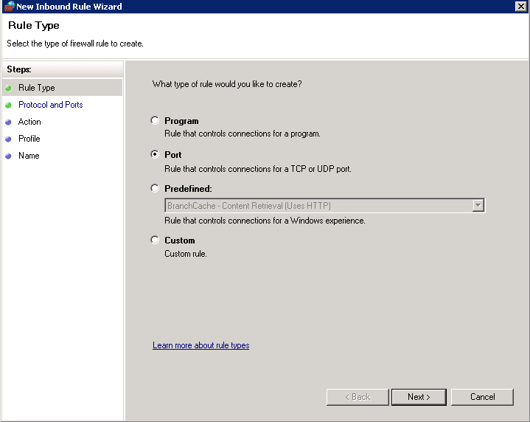

1. On the Port Definition Screen, Select “TCP”, “Specific Local Ports” and enter in all Ports needed by ArcGIS Server. See the example below:

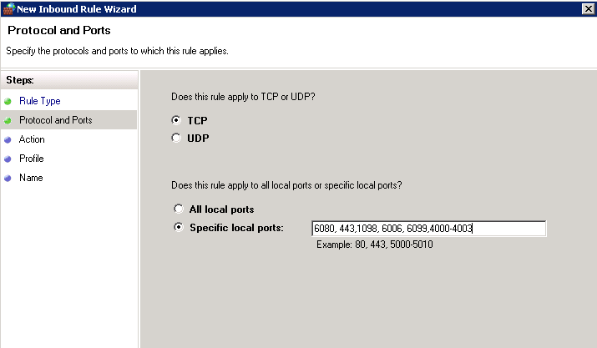

* Enter Ports 4004 – 4012 if you are using clusters.
* Only use port 443 if you are applying SSL.
* If you are not sure what ports to open, Please review the following link.

<http://resources.arcgis.com/en/help/main/10.1/#/Ports_used_by_ArcGIS_Server/015400000537000000/>

1. On the next Screen, select “Allow the Connection” and click Next.

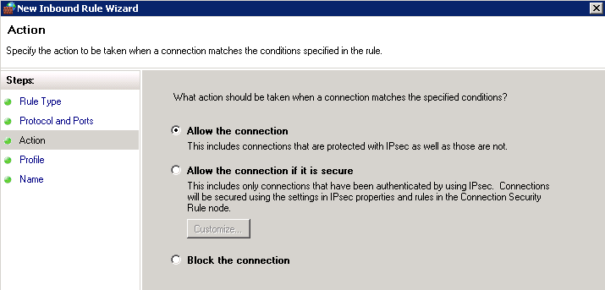

1. Select the Profiles to which this inbound rule will apply. (Ex: Select Private, Public and Domain profiles). Click the “Next” button when complete.

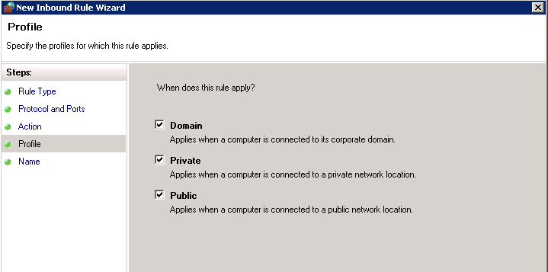

1. Enter in a name for this Inbound Rule and Click “Finish” button.

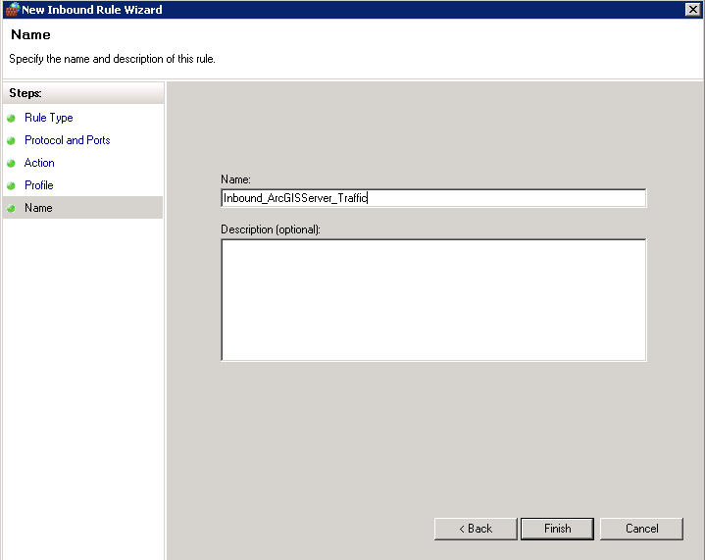

1. Repeat Steps 4 through 9 to create a similar Out-bound rule with the same properties.

# Installation of ArcGIS Server 10.1

1. **Launch installer: ArcGIS_Server_for_Windows_101 installer package.**

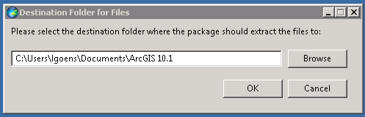

Edit extraction path if necessary and click OK to proceed.

Extraction may take a minute to complete. When finished, you will be prompted to Launch the setup program.

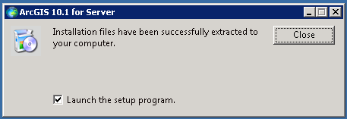

Ensure the *Launch the setup program* checkbox is selected and click Close.

1. **Begin Installation Process**

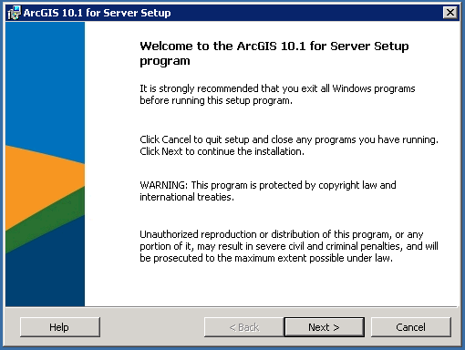

Click Next.

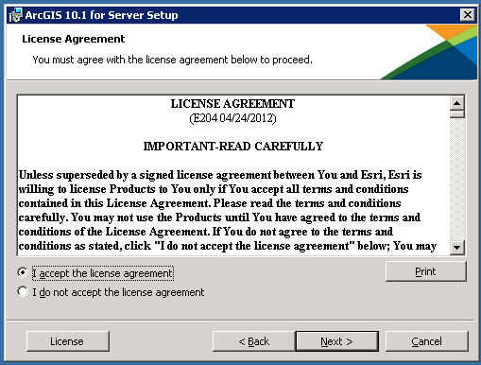

Select the *I accept the license agreement* radio button.

Click Next.

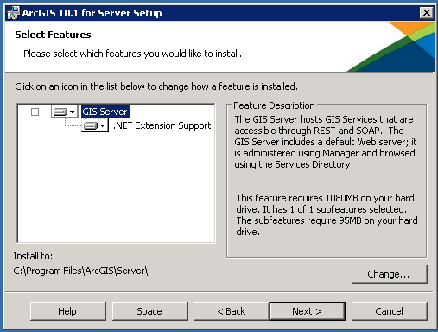

For GIS Server node and .NET Extension Support subnode, leave default options selected.

Change installation location if desired.

Click Next.

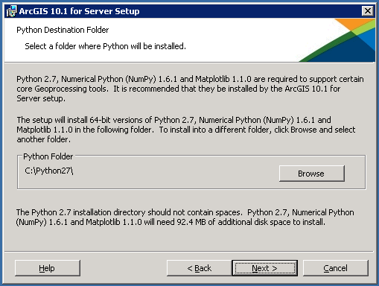

Modify Python installation directory if desired.

Click Next.

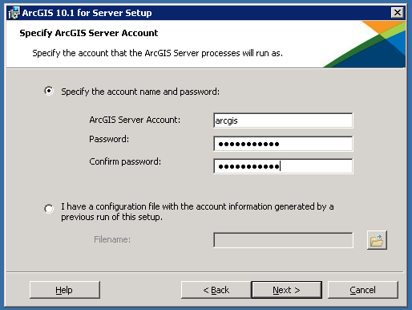

Enter a username (ArcGIS Server Account – Primary Site Administrator)

Enter a ArcGIS Account Password

Retype the password in the Confirm Password field.

Click Next.

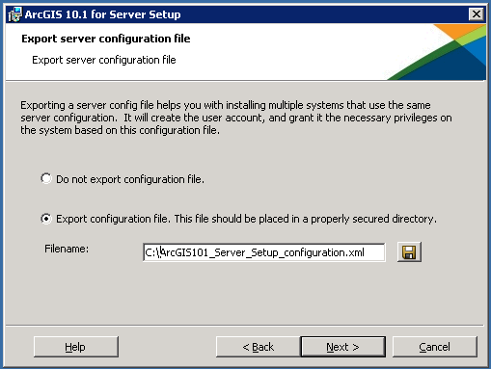

Optionally export a configuration file to be used for installing on multiple systems that will use this configuration.

Click Next.

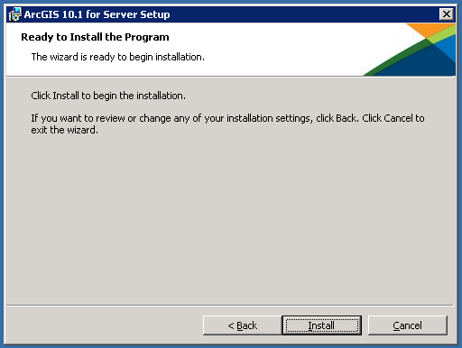

The Setup Wizard is ready to begin the installation.

Click Install.

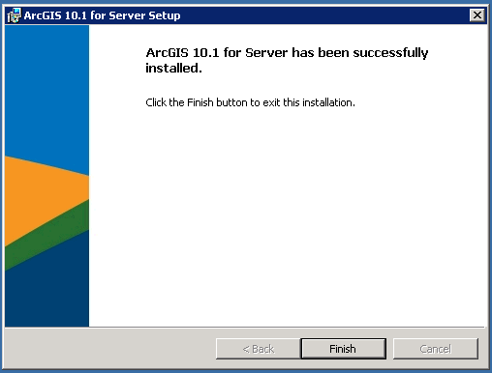

Installation is Complete.

Click Finish to launch the Software Authorization Wizard

1. **Begin Software Authorization Process**

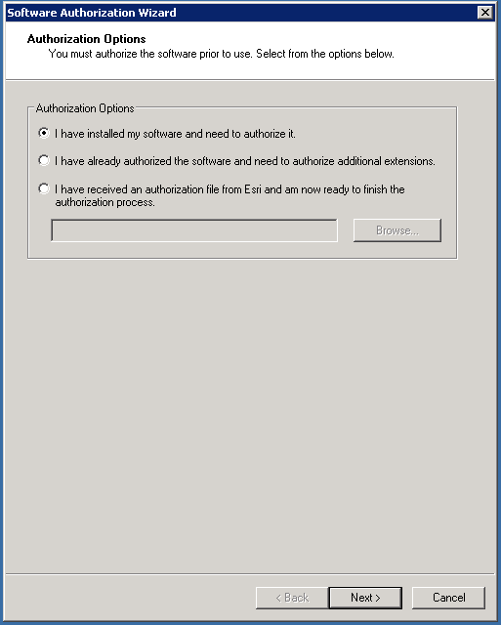

You will need an authorization code or ECP file to authorize your ArcGIS Server 10.1 software.

Select the appropriate mode of authorization and follow the dialog to get your server authorized.

# Configure ArcGIS Server Manager on the GIS Server

1. **For the First GIS Server Installed, select Create New Site.**

* If installing additional GIS Servers that will participate in an existing Site, select Join Existing Site and add the GIS server to the primary GIS Site. Skip to step # 3 to begin.

1. **In a web browser, navigate to :** <http://localhost:6080/arcgis/manager/>

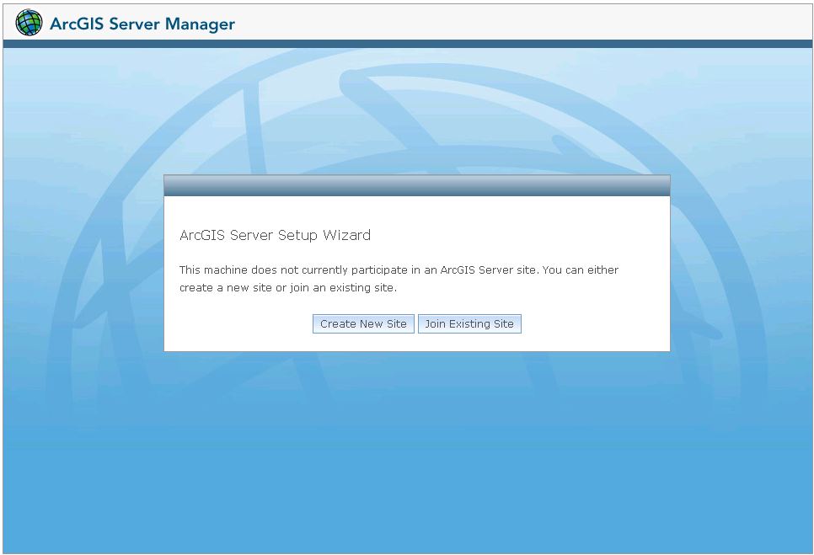

Click Create New Site.

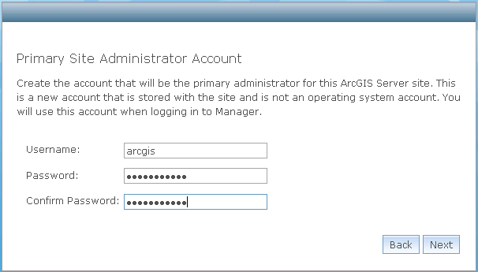

Enter Username and Password for the ArcGIS account that will be the primary administrator for this ArcGIS Server site.

Click Next.

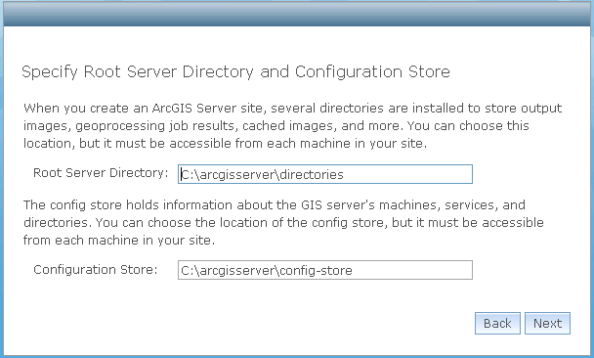

Specify Root Server Directory and Configuration locations. Defaults shown above.

**For a Single Machine Deployment, Use the default path for the config store and the root server direcoty.**

* + - Root Server Directory = C:\arcgisserver\directories
    - Config Store = C:\arcgisserver\config-store

**For a Multiple-Machine Deployment, Use the following path for the config store and the root server direcoty.**

* + - Create a folder share on the server and location of the config store. Typically the arcgisserver directory.
      * Ex: C:\arcgisserver
    - ArcGIS Server Account will need read/write access to the Shared central folder.
    - Root Server Directory = \\{servername}\arcgisserver\directories
    - Config Store = \\{servername}\arcgisserver\config-store
    - ** Any GIS Server participating in a Site will need access to this directory.

Click Next.

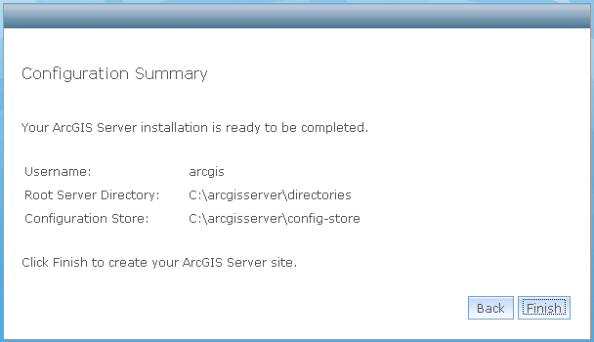

Review the information you entered and if correct, proceed.

Click Finish.

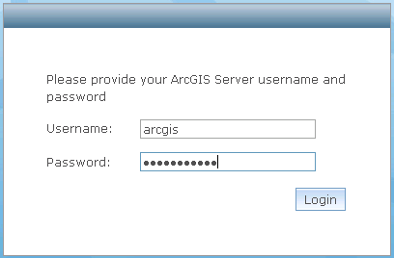

Your site is now created and you can login.

Enter your credentials and click Login to verify.

** In Single Machine, do not execute Step #3 to join an existing site.

1. **In a web browser, navigate to :** <http://localhost:6080/arcgis/manager/>



Click Join Existing Site.

Type the URL to the site you want to join. The URL usually follows the format http://<server name>:6080/.

Type the administrator name and password of the site you want to join. This can be the same user name and password that you used when you created the site, or it can be another ArcGIS for Server user account to whom the server administrator has granted administrative privileges.

Click **Next**.

Examine the configuration summary and click **Finish** when you are ready to join the machine to the site.

# Installation of ArcFM Server 10.1

1. **Install ArcFM Server 10.1**

Launch installer: ArcFM_Server1010

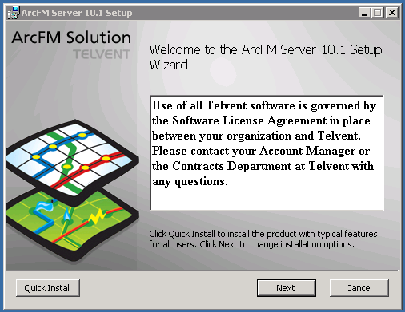

Click Next.

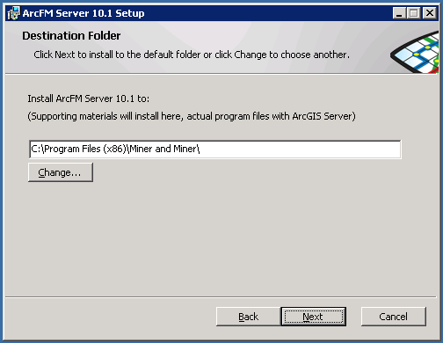

Change installation directory if desired.

Click Next.

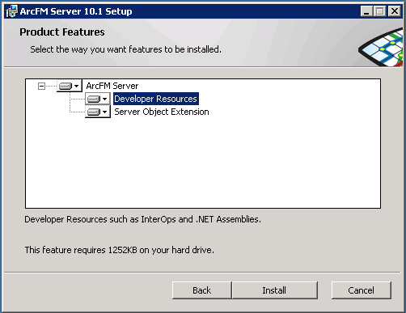

Install Developer Resources if installing a development server.

Click Install.

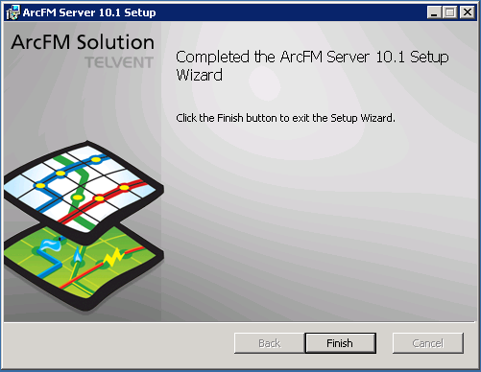

Installation is complete.

Click Finish.

1. **Set the ArcFM License Server.**

Go To Start Menu > All Programs > ArcFM Solution > ArcFM Server

Click on “Set ArcFM Server License Server”.

Enter in the name of your ArcFM Server License Server.

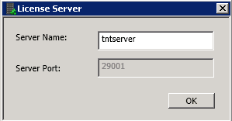

Click OK to complete configuration of the license server.

1. **Register The ArcFM Server Object Extension**

After completing the installation of ArcFM Server 10.1 in the steps above, you should have a new item in your Windows Start menu. Open *Register ArcFM SOE.* You may also find shortcuts to it here:

Go To Start Menu > All Programs > ArcFM Solution > ArcFM Server > Register ArcFM SOE

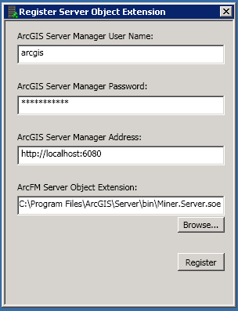

In the Register Server Object Extension, enter your user name and password for ArcGIS Server primary site administrator.

Enter the ArcGIS Server Manager Address. (Default vale shown above).

Browse to your ArcFM Server Object Extension.   
 C:\Program Files\ArcGIS\Server\bin\Miner.Server.soe in this example.

Click Register.

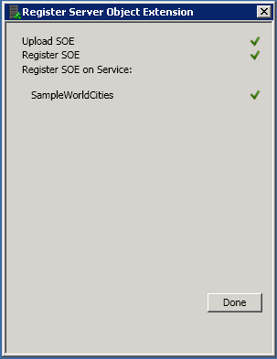

Once registered, you should see the above dialog window.

Click Done.

# Install ArcGIS Server Styles and True Type Fonts

1. **If Server Styles do not exist, Make the Server Style.**

* On a machine with ArcGIS 10.1 Desktop Installed.
* Open windows explorer, navigate to:

*C:\Program Files (x86)\ArcGIS\Desktop10.1\bin*

* Double click on MakeServerStyleSet.exe.

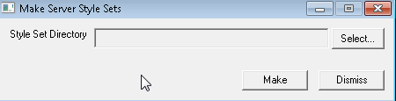

* Select the directory that has the most recent version of the PG&E_Take5.style file.
* Click the “Make” button to convert the desktop style to a server style.
* The file PG&E_Take5.ServerStyle is created in the directory selected.

1. **Copy the Server Style file to the GIS Server.**

* On the GIS Server, Open a windows explorer and navigate to:

*D:\Program Files\ArcGIS\Server\Styles*

* Paste the PG&E_Take5.ServerStyle created in Step #1 to this directory.

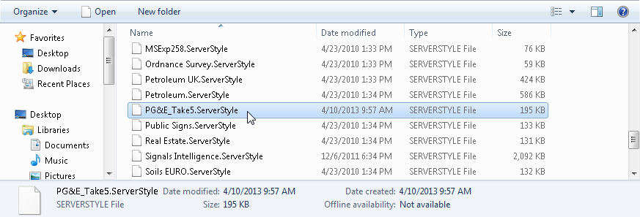

1. **Install the True Type Font File on each GIS Server.**

* Get the most recent version of the PG&E ED Distribution Map1.ttf file.
* Copy this file onto the GIS Server.
* Open a windows explorer, navigate to the True Type Font file, right click and select install from the menu.

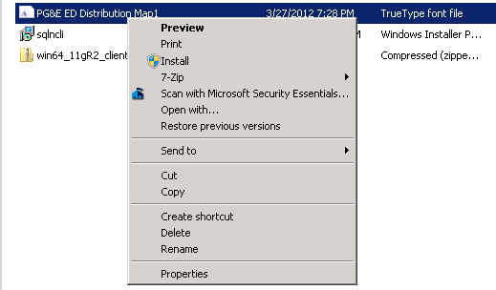

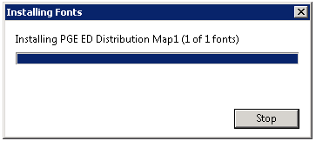

**Web Server Machine Installs**

**(Installation steps for all Web Servers)**

# Web Server Pre-Requisite Installs

***\*\*\*\*\*\*\*\* (In a single machine deployment the Web Server and GIS Server components co-exist on the same physical machine)***

**1) Operating System = Windows Server 2008 R2**

**2) Server 2008 Features Enabled = Microsoft IIS 7.0 Feature is enabled and configured.**

**3) Confirm that Microsoft.Net Framework 4 Client Profile is installed.**

- If it’s not installed, download and install.

<http://www.microsoft.com/en-us/download/details.aspx?id=17113>

**4) Confirm that Microsoft.Net Framework 4 Extended is installed.**

- If it’s not installed, download and install.

<http://www.microsoft.com/en-us/download/details.aspx?id=17718>

**5) Confirm that ASP.Net 4.0 has been registered with and is enabled with IIS.**

- If it hasn’t been registered with IIS, run the following Commands from a DOS prompt:

- %SYSTEMROOT%\Microsoft.NET\Framework\v4.0.30319\aspnet_regiis.exe -i -enable

- iisreset

**6) Check that the proper IIS Features are enabled.**

When the setup program launches, it checks IIS for proper configuration before it will proceed with the Web Adaptor installation. You may see a failure reported that will need to be resolved prior to continuing with the installation. Below is an example of missing IIS Role Services.

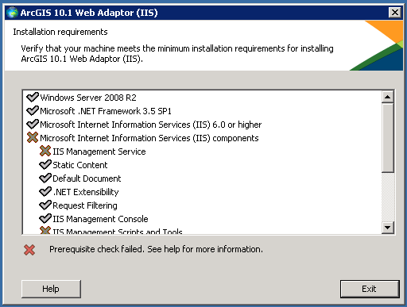

If you have missing requirements, click the Help button to diagnose.

In this instance, a web page is opened and information is presented on how to find which components are missing that is preventing installation.

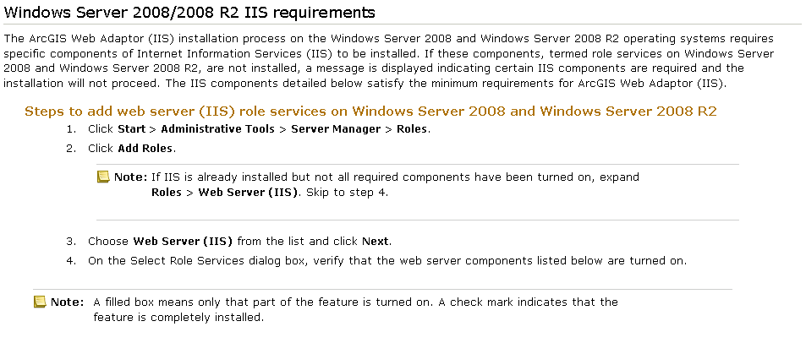

In this case it, the problem is related to IIS Role Services. The webpage documentation describes how to get the the Roles administration section within your server’s Administrative Tools application.

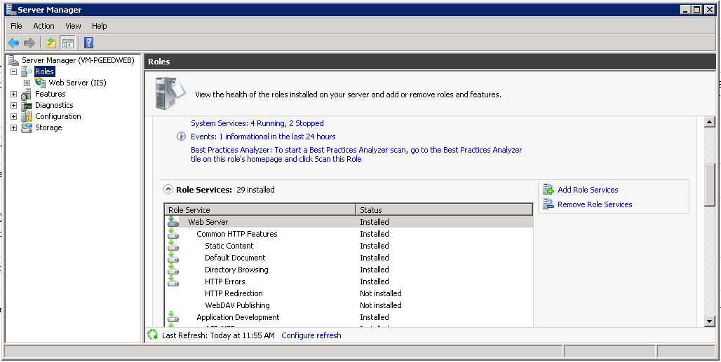

After navigating to the Roles section within Server Manger, it is determined that *IIS Management Scripts and Tools* and *Management Service* roles are not installed. To install them, navigate to the top of the Role Services section and locate the *Add Role Services* link in the right pane.

Click Add Role Services.

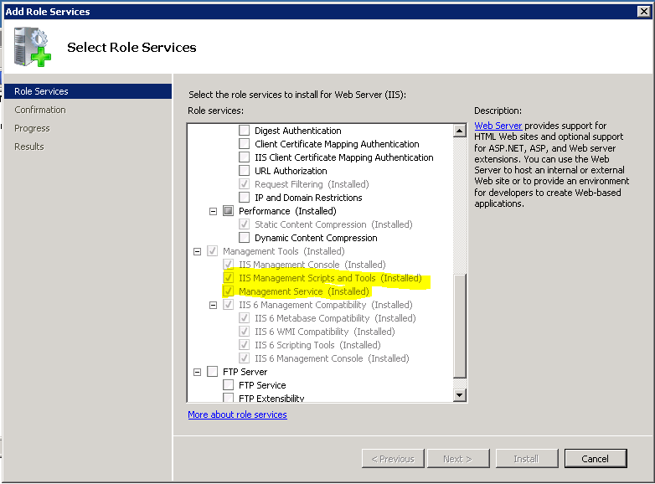

Navigate to the role that needs to be installed and select the check box next to the item.

Note: The above screenshot was taken after the additional roles were installed. Initially the two highlighted options were not checked. The instructions are accurate however. Check the check boxes next to the components to add and complete the installation wizard.

Click Install.

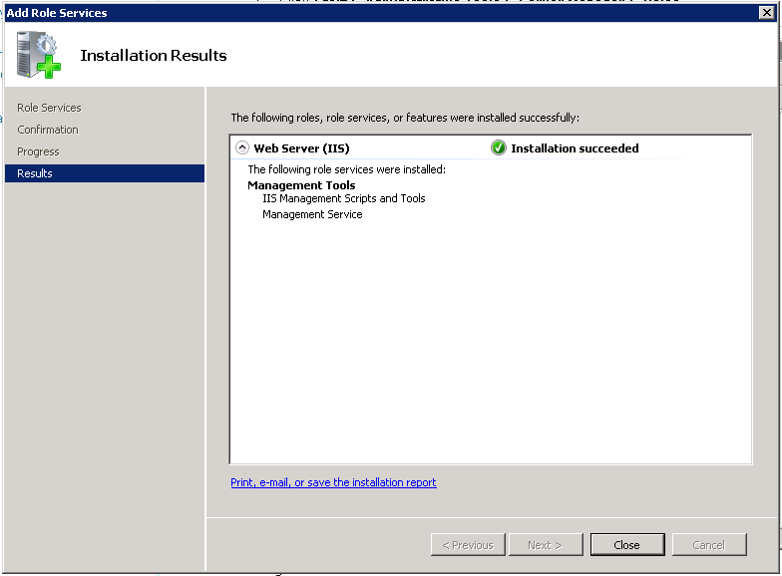

When finished, you should see that the roles you selected were installed (listed under *The following role services were installed:* heading).

Click Close.

# Shut off Firewall or Open ArcGIS Server Ports

***\*\*\*\*\*\*\*\* (This Step is only needed for Multiple Machine Deployments)***

Follow steps outlined in the ArcGIS Server Machine install section for Shutting off Firewalls or opening ArcGIS Server specific ports.

# Install ArcGIS 10.1 Web Adaptor

1. **Open ArcGIS Server 10.1 Web Adaptor Installer**

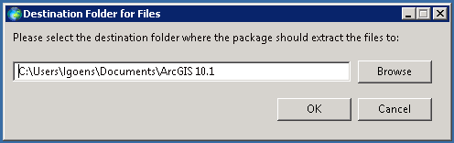

Select destination folder where Web Adaptor files should be extracted to (default values shown).

Click Ok.

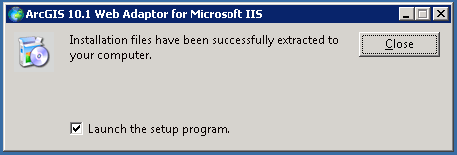

Following extraction, you’ll see the following dialog.

Ensure Launch the setup program option is checked.

Click Close.

1. **You should see the following dialog window:**

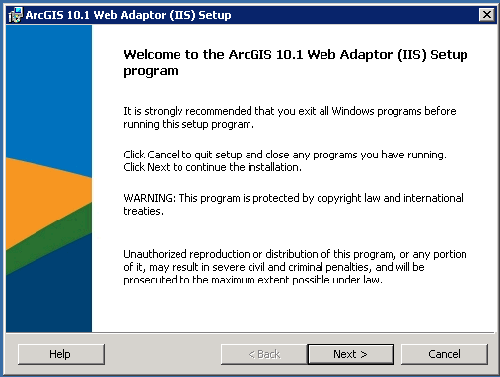

Click Next.

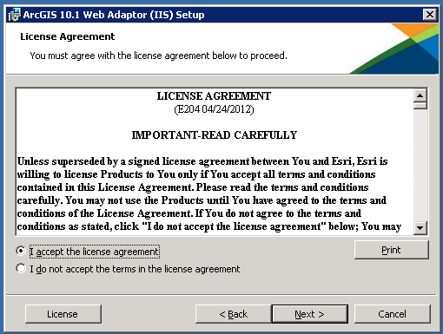

Select the I acceptance radio button.

Click Next.

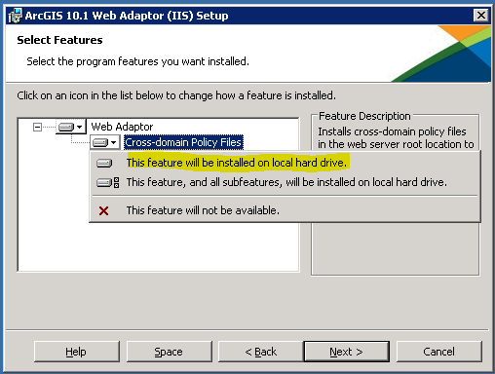

Under Web Adaptor, select Cross-domain Policy Files to be installed on the local hard drive.

Click Next.

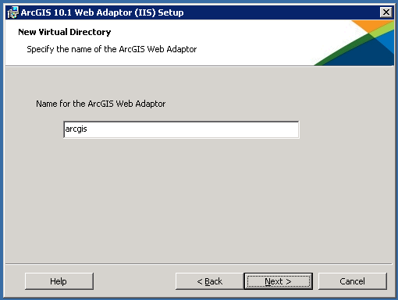

Enter a name for the ArcGIS Web Adaptor (default value shown).

Click Next.

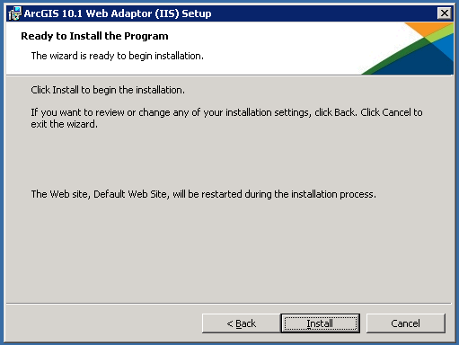

The installation wizard is ready to instal the Web Adaptor.

Click Install.

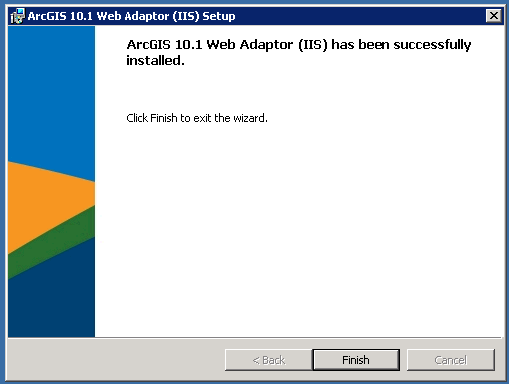

Installation is Complete.

Click Finish.

1. **Configure the Web Adaptor**

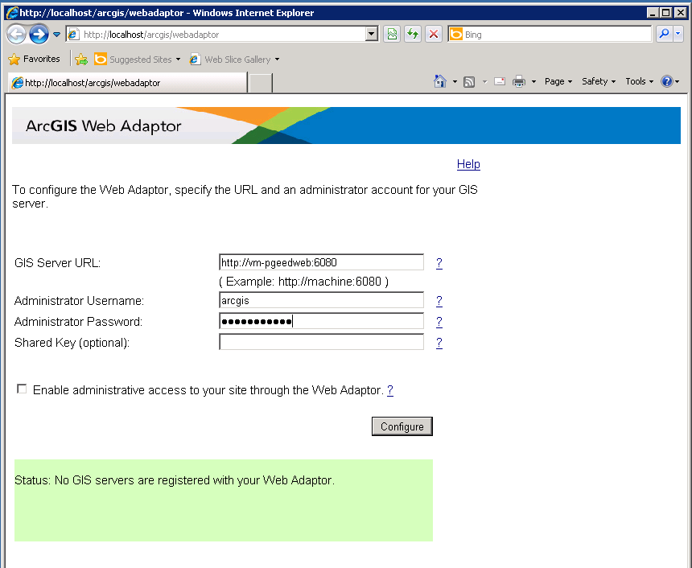

Enter the GIS Server URL for the Primary GIS Site, ArcGIS Primary Site Username, and Password.

Click Configure.

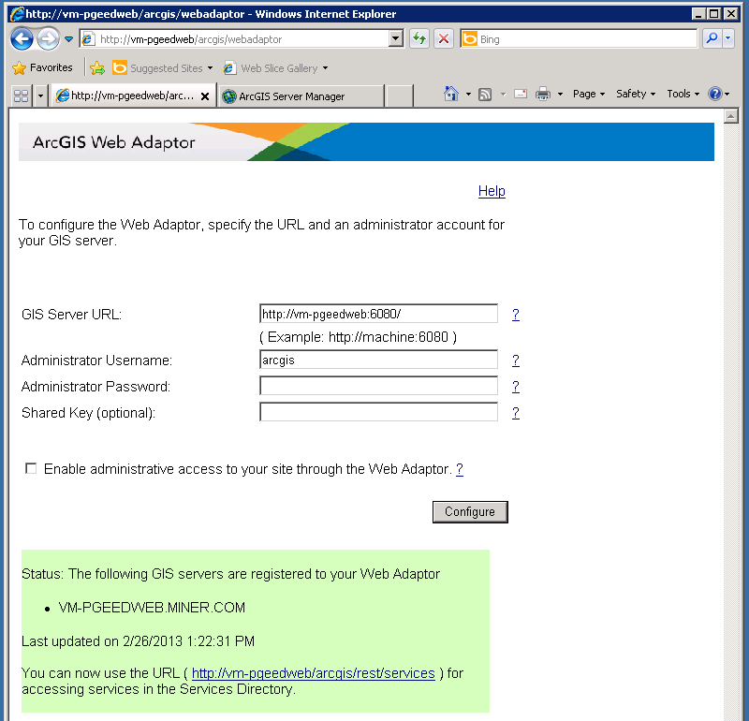

You should see an updated Status reporting that your GIS Server is now registered to your Web Adaptor.

Your Web Adaptor is now installed and configured.

# Install PG&E Silverlight – ED Viewer on All Web Servers

1. **In IIS Manager, create an application pool called “ArcFMSilverlight” with the following properties.**

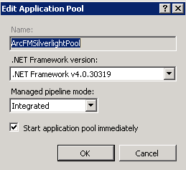

1. **Locate and double click on the the PGnE.EDViewer.Installer.msi in a windows explorer.**

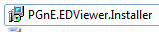

1. **At the Welcome screen, click the “Next” button to continue with the install.**

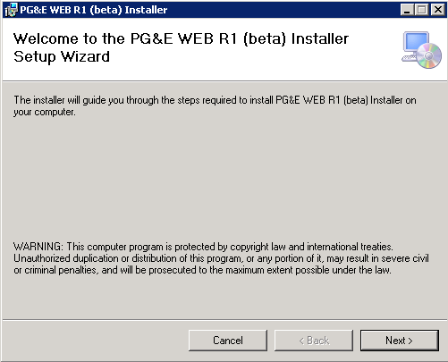

1. **At the installation address screen, select the following and click “Next” to continue.**

* Site = {IIS instance to deploy the app to} {“Default Site” is the default setting}
* Virtual Directory = { EDViewer }
* Application Pool = {ArcFMSilverlightPool}

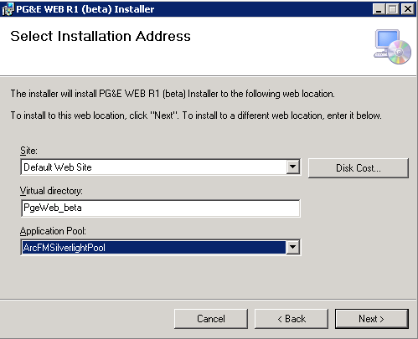

1. **At the installation confirmation screen click “Next” to start the install.**

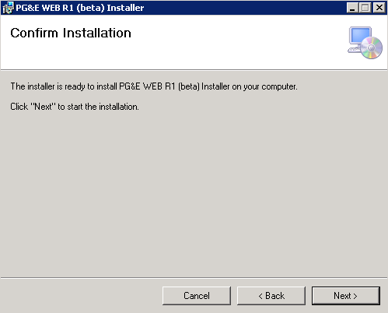

1. **At the installation complete screen, click the Close button to complete the install.**

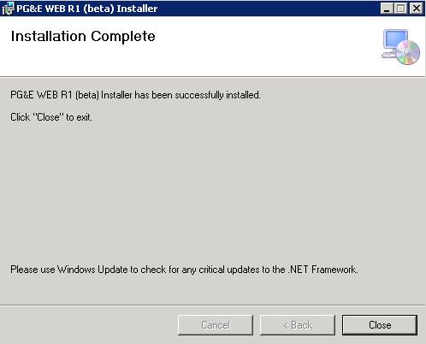

1. **Enable Windows Authentication on the application.**

* In IIS Manager go to EDViewer > Features View > Authentication.

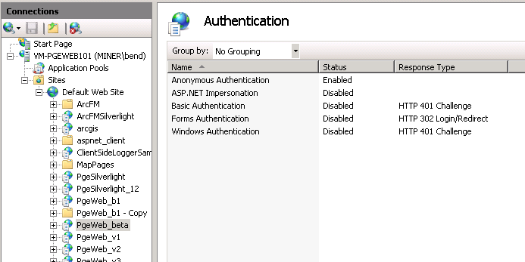

* Disable Anonymous Authentication.
* Enable Windows Authentication.

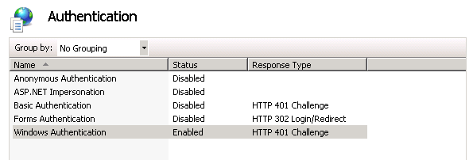

1. **Enable Server Side logging.**

* Open Windows Explorer.
* Navigate to [IIS Root]\EDViewer
* Right Click on the Logs directory and select properties.
* Go to the Security tab.
* Add Read\Write permissions for the IIS_IUSR local account.

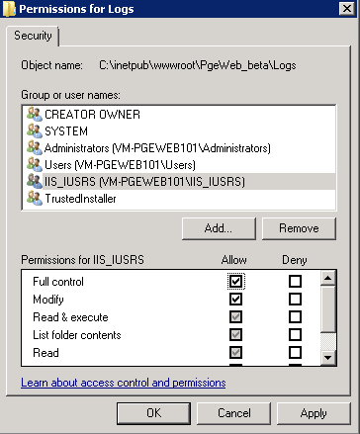

1. **Move on to Configuring the Application with valid resources.**

**Service Publishing Machine Configuration**

**(Installation steps for all Publishing Machines)**

**Service Publishing Machine Pre-Requisite Installs**

**1) OS = Windows 7**

**2) ArcGIS Desktop 10.1 is installed and licensed**

**3) ArcFM 10.1 is installed and licensed.**

**4) ArcGIS_VBA_Compatibility_101 components are installed and licensed.**

**5) Oracle 32 bit client software has been installed.**

**6) Valid tnsnames.ora and sqlnet.ora files in oracle home\Netowrk\admin directory.**

**7) Valid tnsnames.ora file in the C:\ProgramData\TNS_ADMIN directory.**

**8) PGE True Type Fonts are installed on this machine.[ PG&E ED Distribution Map1.ttf ]**

**9) PGE ArcGIS Style File is installed on this machine. [PG&E_Take5.style]**

**Create Database Connections for Publishing**

* Open ArcCatalog.
* In the left Panel, expand the “Database Connections” node.
* Double Click on “Add Database Connection”.

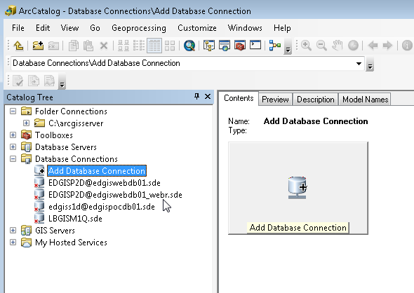

* The Add Database Connection dialog appears.

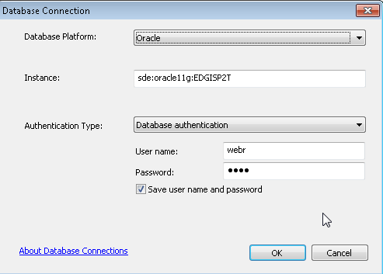

* Enter The following Properties to create a connection the ED GIS Data Instance:
  + Database Platform:
    - Select Oracle.
  + Instance:
    - sde:oracle11g:EDGISP2T
  + Authentication Type:
    - Select Database Authentication.
  + User name and Password:
    - webr/webr
* Click the “OK” button to create the connection.
* Name your connection in ArcCatalog.
* Click the Add Database Connection from ArcCatalog to create a second data connection.

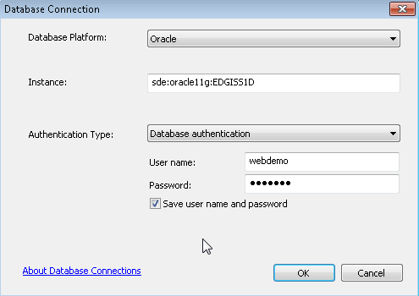

* Enter The following Properties to create a connection the WIP Data Instance:
  + Database Platform:
    - Select Oracle.
  + Instance:
    - sde:oracle11g:EDGISW1T
  + Authentication Type:
    - Select Database Authentication.
  + User name and Password:
    - webr / webr
* Click the “OK” button to create the connection.
* Name your connection in ArcCatalog.
* Click the Add Database Connection from ArcCatalog to create a third data connection.

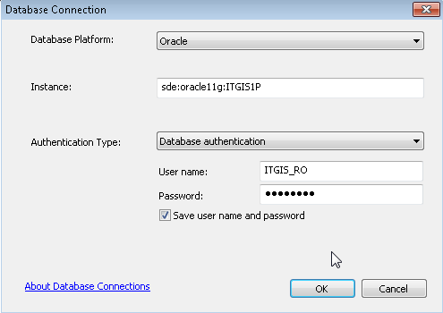

* Enter The following Properties to create a connection the Landbase Data Instance:
  + Database Platform:
    - Select Oracle.
  + Instance:
    - sde:oracle11g:ITGIS1p
  + Authentication Type:
    - Select Database Authentication.
  + User name and Password:
    - ITGIS_RO / ITGIS_RO
* Click the “OK” button to create the connection.
* Name your connection in ArcCatalog.

# Create an Administrative Connection to the ArcGIS Site

1. **Open ArcCatalog.**
2. **In the left panel, expand the GIS Servers node.**

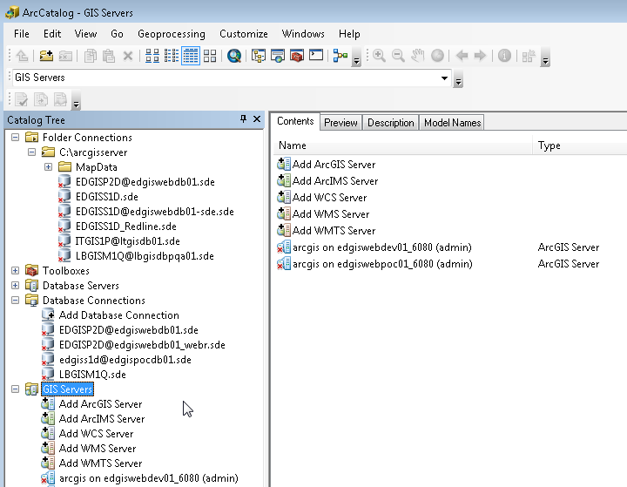

1. **Double Click on “Add ArcGIS Server” and select “Administer GIS Server”.**

Click the “Next” button to continue.

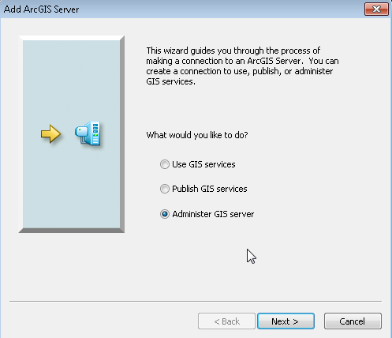

1. **Define the parameters of the connection.**

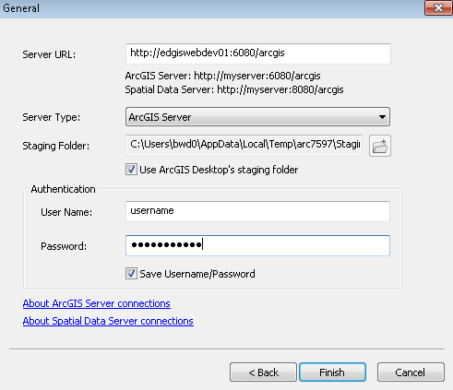

* Server URL = http://{servername}:6080/arcgis
* Server Type = ArcGIS Server
* UserName / Password = GIS Server Primary Site Manager user name and password.

1. **Click Finish to create the Connection.**

# Register Data Stores with the ArcGIS Site

1. **Open ArcCatalog.**
2. **In the left panel, expand the GIS Servers node.**
3. **Find the GIS Server Connection Created in the previous step.**
4. **Right Click. Select “Connect”.**

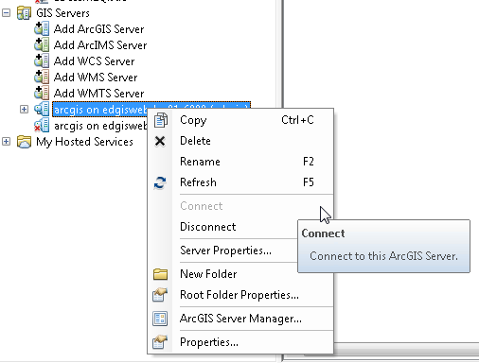

1. **After Connecting, Right Click again on the GIS Server node.**
2. **From the Dropdown, select “Server Properties”.**

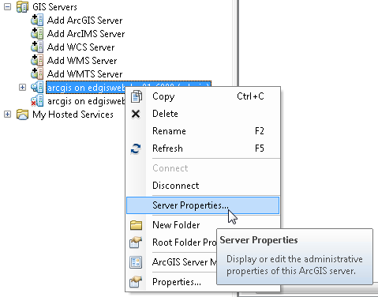

1. **From the Server Properties Dialog, select the Data Stores tab.**

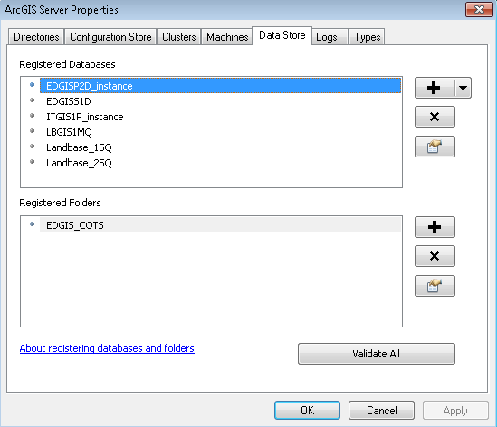

1. **Click on the “Add Database Store” button.**

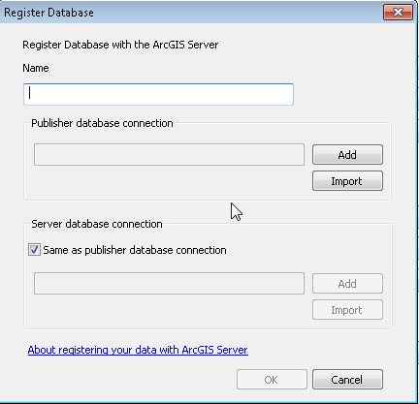

Enter a name for the data store.

Select the SDE File created in previous steps to create data connections. Create a data store for each SDE data source.

* + EDGISP2T – Add a Data Store for this data source.
  + EDGISW1T – Add a Data Store for this data source.
  + ITGIS1P - Add a Data Store for this data source.

1. **Click “OK” to register the data store.**
2. **Register the COTS data folder as a data store with ArcGIS Server.**
3. **From the Server Properties Dialog, select the Data Stores tab.**



1. **Click on the “Register Folder” Add button.**

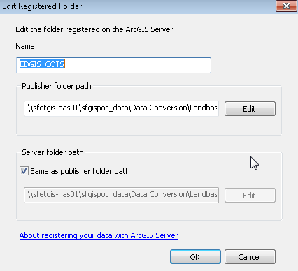

1. **Enter a data store name and enter the publisher folder path.**
2. **Click “Ok” button to register.**

**Create the WIP and Redline Data Stores**

***Create the WIP Classes***

1. **In ArcCatalog, open the data connection to EDGISW1T database.**
2. **Create a new Feature Dataset called WIPRedlines**

* **WIPRedlines**
* **Use the PG&E standard spatial reference.**

1. **In the WIPRedlines Data Set, Create the WIP polygon class with the following definition.**

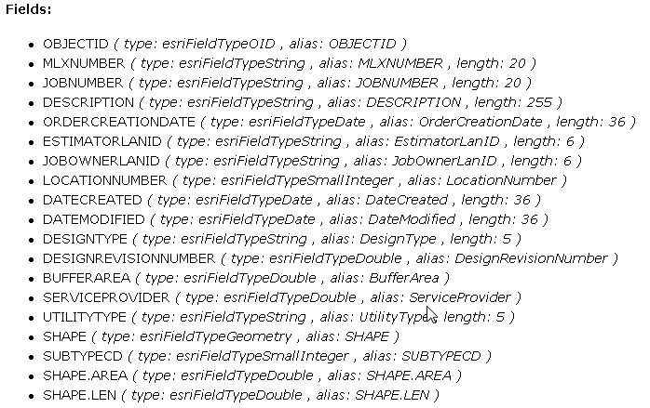

1. **Create the PMOrder Table in W1T database with the following structure.**

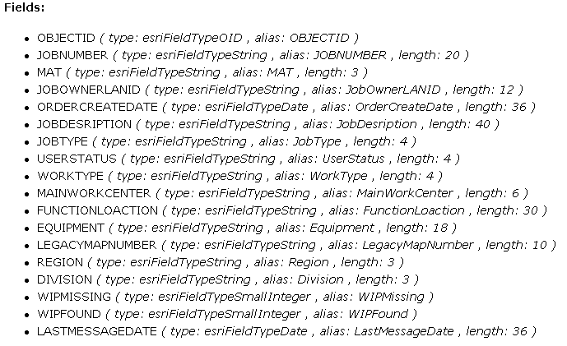

**5) Within the WIPRedline Dataset, Create the PMOrder_WIP Relationhsip class in W1T database with the following structure.**

|  |  |
| --- | --- |
| **PMOrder_WIP Relationship** | |
| Name | PMOrder_WIP |
| Cardinality | 1:M |
| Source Class | PMOrder |
| Destination Class | WIP |
| Source Field | JobNumber |
| Destination Field | JobNumber |
| Message Propagation | None |
| Composite | No |

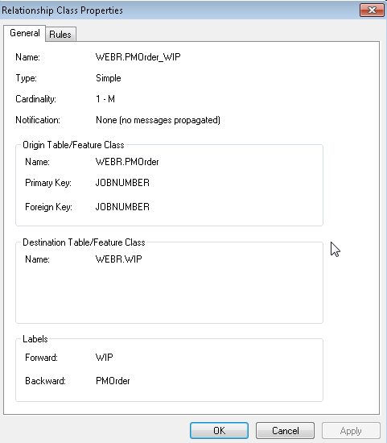

**6) Configure Subtypes for the WIP Feature Class**

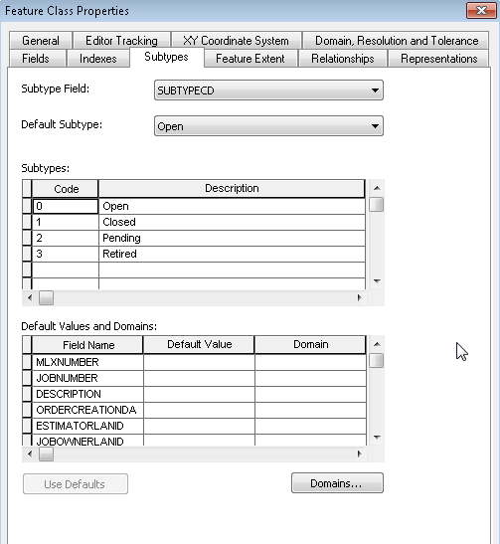

**7) Create the WIP Label Point Feature Class**

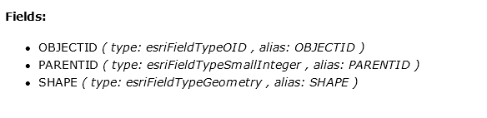

***Create the Redline Classes***

1. **In ArcCatalog, open the data connection to EDGISW1T database.**
2. **Create a new Feature Dataset called Redlines.**

* **Redlines**
* **Use the PG&E standard spatial reference.**

1. **In the Redlines Data Set, Create the Following classes with the following definition.**

***Create the Text Redline Feature Class***

* **Create the redline text feature class and configure the following fields.**
* **Feature Class: Point Feature Class**
* **Required Fields:**

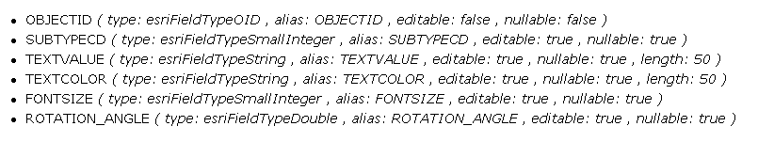

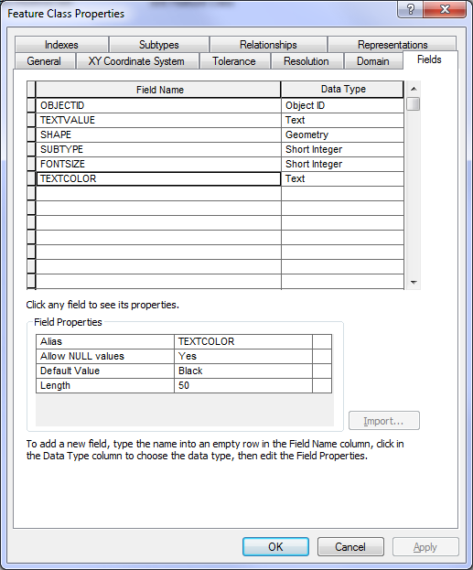

* **Configure Subtypes for Text Features**

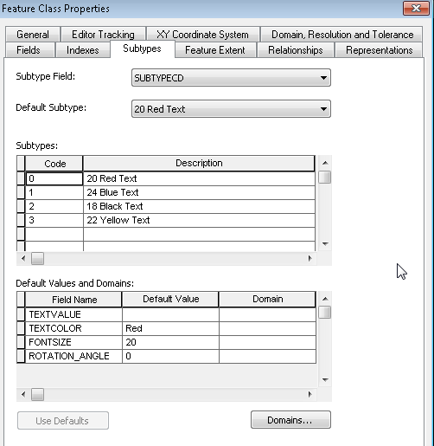

***Create the Polygon Redline Feature Class***

* **Create the redline polygon feature class and configure the following fields.**
* **Feature Class: Polygon Feature Class**
* **Required Fields:**

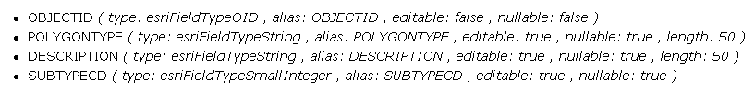

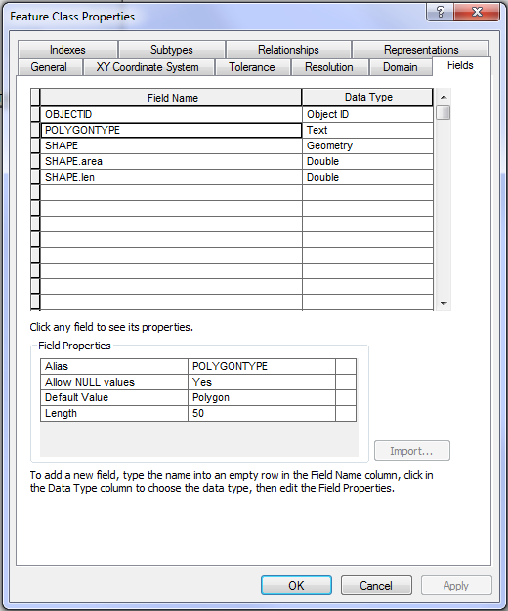

* **Configure Subtypes for Polygon Features**

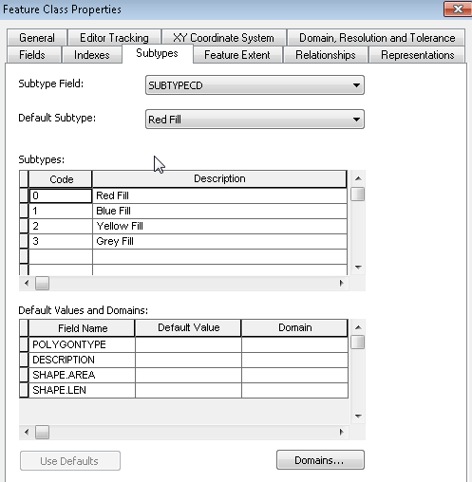

***Create the Polyline Redline Feature Class***

* **Create the redline polyline feature class and configure the following fields.**
* **Feature Class: Polyline Feature Class**
* **Required Fields:**

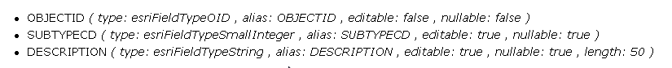

* **Configure Subtypes for Polyline Features**

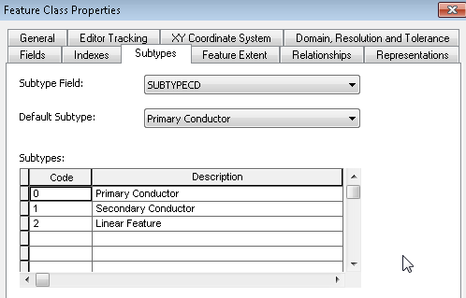

***Create the Point Redline Feature Class.***

* **Create the redline points feature class and configure the following fields.**
* **Feature Class: Point Feature Class**
* **Required Fields:**

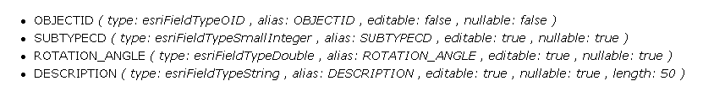

* **Configure Subtypes for Point Features**

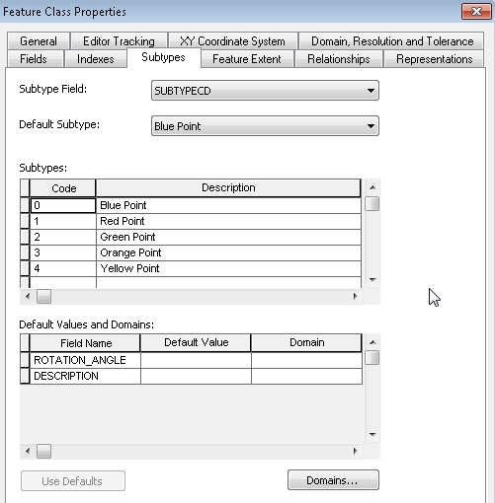

# Feature Edit Templates - Set Up Feature Services

***Setup the Feature Services***

Version: 10.1

This section discusses how to create feature services. Feature services are map services with feature capabilities enabled. Follow the steps below. In this first set of steps, you'll create an MXD file that contains your redline features.

1. Open ArcCatalog and ensure the database connection properties to the WIP data source are configured properly.

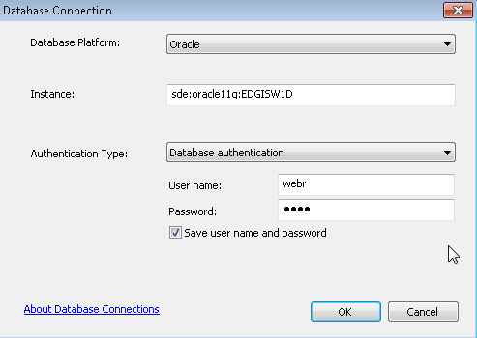

1. Next, for both WIPRedlines and Redlines Feature Dataset, Register as Versioned with option to move edits to base.

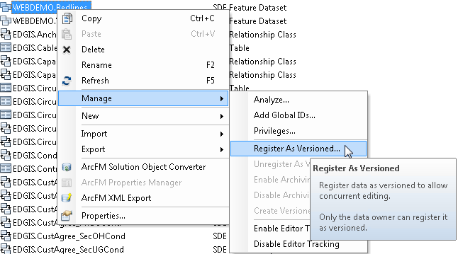

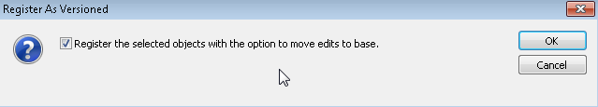

1. Open ArcMap. Do not login to ArcFM (see next step).
2. When prompted click Cancel to dismiss the ArcFM login screen.
3. Click Yes to verify that you want to cancel the login screen.

*ArcFM uses a login object to store the connection information. If you cancel the ArcFM login, the connection information can then be stored with the MXD file.*

1. Add the redlining layers to an empty map.

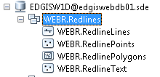

1. Modify the symbology.

**Text:** Right-click the text layer and select Properties. On the Symbology tab, you can set the symbology for text layers. **All symbols must be transparent**. You may want to set the symbol to a larger point size in order to make it easier for the user to click the hidden point symbol on the map and edit the text.

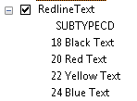

**Polygons, Lines, and Points:** You can modify the symbology for your polygons, lines and points. Right-click the layer in the ArcMap Table of Contents and select Properties. On the Symbology tab determine the fill and outline colors for polygons or the color/thickness for lines or the color/graphic to use for points.

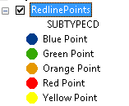 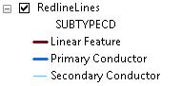

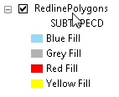

1. Once you've finished editing the feature symbology, select File > Save As and save the MXD as Redline_testdata.mxd. You will need this later to create the feature service.
2. Close ArcMap.
3. Open ArcMap and do not login to ArcFM.
4. When prompted click Cancel to dismiss the ArcFM login screen.
5. Click Yes to verify that you want to cancel the login screen.

*ArcFM uses a login object to store the connection information. If you cancel the ArcFM login, the connection information can then be stored with the MXD file.*

1. Add the WIP Redline layers to an empty map.

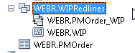

Add the WIP Feature Class and the PMOrder Table.

1. Modify the WIP Class symbology.

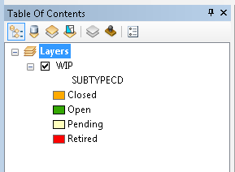

1. Once you've finished editing the feature symbology, select File > Save As and save the MXD as WIPRedline_testdata.mxd. You will need this later to create the feature service.
2. Close ArcMap.

***Create the Edit Templates***

Next you'll set up the edit templates for all features. Execute this step for both the Redline MXD layers and the WIP Redline MXD Layers.

1. Open the WIPRedline_testdata.mxd containing the WIP Reldine WIP feature Class. Do not sign into ArcFM.
2. Right-click any layer on the Table of Contents tab in ArcMap and select Edit Features > Organize Feature Templates.

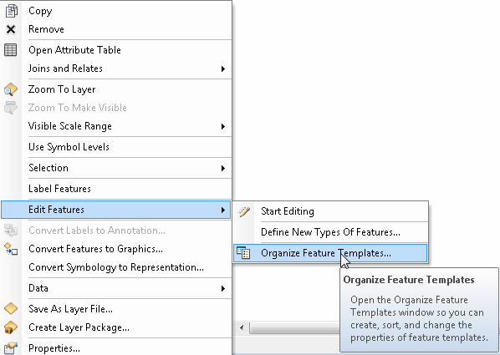

1. Click the New Template button.
2. Select the checkboxes for all of your WIP redline features and click Next. If you have created no feature layers with subtypes, click Finish and skip step 4.

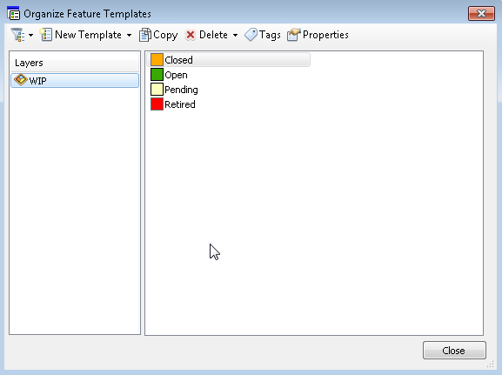

1. If you have created any feature layers with subtypes, you will be prompted to choose a subset of subtypes, if desired. By default all subtypes are selected. Click Finish.
2. Click Close.
3. Save the MXD and close ArcMap.
4. In the next steps, you'll create the feature services.
5. Open the Redline_testdata.mxd containing the WIP Reldine WIP feature Class. Do not sign into ArcFM.

*** Create Feature Edit Templates for all Feature Layer in the Redline_testdata.mxd. Execute steps 10 through 16 for all layers.

1. Right-click any layer on the Table of Contents tab in ArcMap and select Edit Features > Organize Feature Templates.



1. Click the New Template button.
2. Select the checkboxes for all of your WIP redline features and click Next. If you have created no feature layers with subtypes, click Finish and skip step 4.

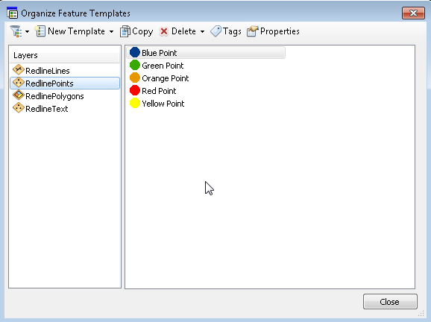

1. If you have created any feature layers with subtypes, you will be prompted to choose a subset of subtypes, if desired. By default all subtypes are selected. Click Finish.
2. Click Close.
3. Save the MXD and close ArcMap.
4. In the next steps, you'll create the feature services.

# Publish Redline Feature Service

1. Open the Redline_testdata.mxd in ArcMap. Do not sign into ArcFM.
2. Once the Document opens, go to File > Share As > Serive.

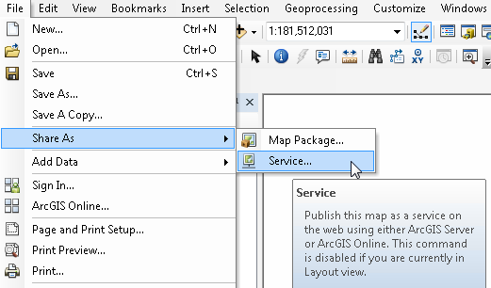

1. Select “Publish Service” and click the next button.

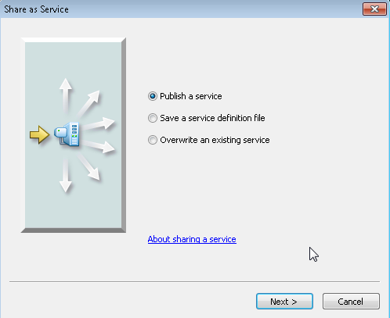

1. Enter the Service name “Redlines_testdata”, select the ArcGIS Server Site to publish the service to and click the next button.

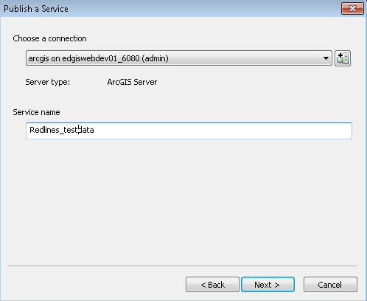

1. Select the folder to that the service should be published into and click the continue button.

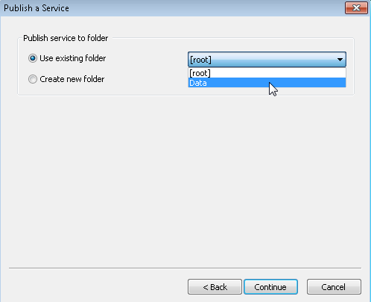

1. The Service Editor will display. Select the Capabilities section and enabled only the following:

* Mapping
* ArcFMMapServer
* Feature Access

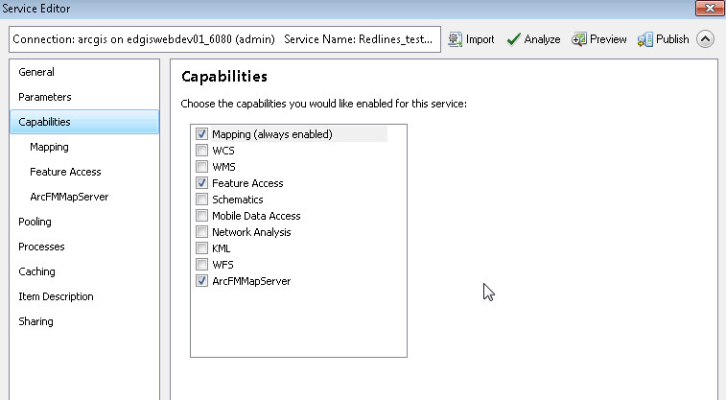

1. After enabling Feature Access, click on the capability “Feature Access” node in the left panel.

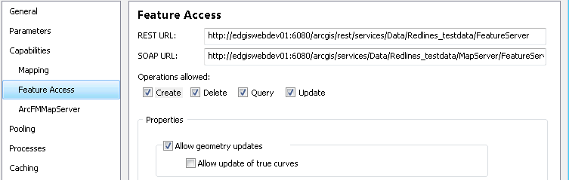

1. Uncheck the Create check box.
2. In the upper right hand corner of the Service Editor, click “Analyze” to execute the Publishing checks on the MXD and its layers.

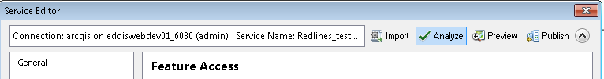

1. Look at the analyze results to assure no errors are blocking the publishing.

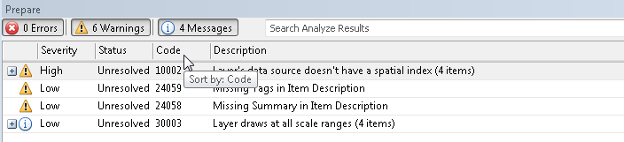

1. In the upper right hand corner of the Service Editor, click “Publish” to execute the Publishing of the map/feature service.
2. When it’s complete, click “OK” on the publish succeeded message box.

# Publish WIP Redline – Edit Feature Service

1. Open the WIPRedline_testdata.mxd in ArcMap. Do not sign into ArcFM.
2. Once the Document opens, go to File > Share As > Serive.



1. Select “Publish Service” and click the next button.



1. Enter the Service name “WIPRedlines_edt”, select the ArcGIS Server Site to publish the service to and click the next button.

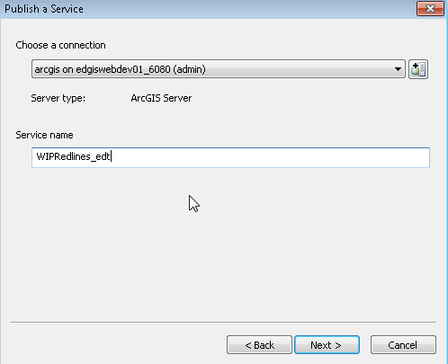

1. Select the folder to that the service should be published into and click the continue button.



1. The Service Editor will display. Select the Capabilities section and enabled only the following:

* Mapping
* ArcFMMapServer
* Feature Access



1. In the upper right hand corner of the Service Editor, click “Analyze” to execute the Publishing checks on the MXD and its layers.



1. Look at the analyze results to assure no errors are blocking the publishing.



1. In the upper right hand corner of the Service Editor, click “Publish” to execute the Publishing of the map/feature service.
2. When it’s complete, click “OK” on the publish succeeded message box.

# Publish WIP Redline – Search Service

1. Open the WIPRedline_testdata.mxd in ArcMap. Do not sign into ArcFM.
2. Once the Document opens, go to File > Share As > Serive.



1. Select “Publish Service” and click the next button.



1. Enter the Service name “WIPRedlines_search”, select the ArcGIS Server Site to publish the service to and click the next button.

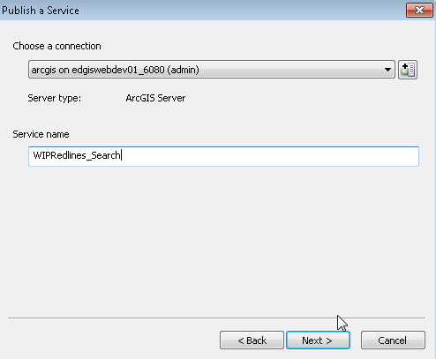

1. Select the folder to that the service should be published into and click the continue button.



1. The Service Editor will display. Select the Capabilities section and enabled only the following:

* Mapping
* ArcFMMapServer
* Feature Access



1. In the upper right hand corner of the Service Editor, click “Analyze” to execute the Publishing checks on the MXD and its layers.



1. Look at the analyze results to assure no errors are blocking the publishing.



1. In the upper right hand corner of the Service Editor, click “Publish” to execute the Publishing of the map/feature service.
2. When it’s complete, click “OK” on the publish succeeded message box.

# Publish Publication Feature Service

1. Open PublicationFS.mxd in a publishing machine with edpub TNS set to the same destination as the ArcGIS Server machine’s edpub TNS.
2. File > Share As > Service…
3. Publish a service
4. Name is Publication FS
5. Choose the Data folder
6. Under Capbilities uncheck KML and check Feature Access  
   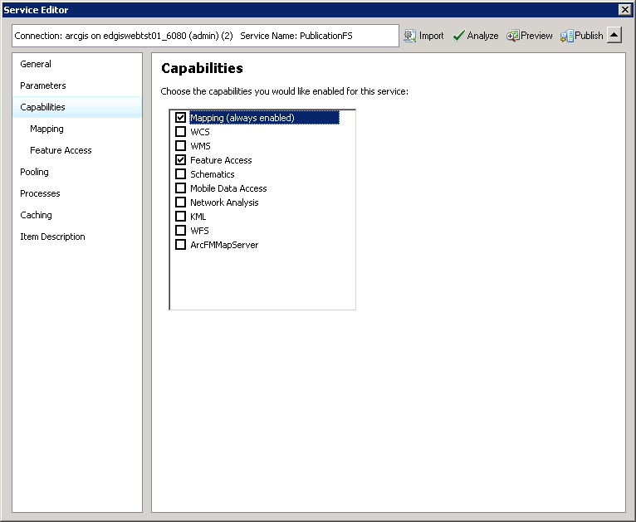
7. Under Feature Access uncheck Create, Delete and Update  
   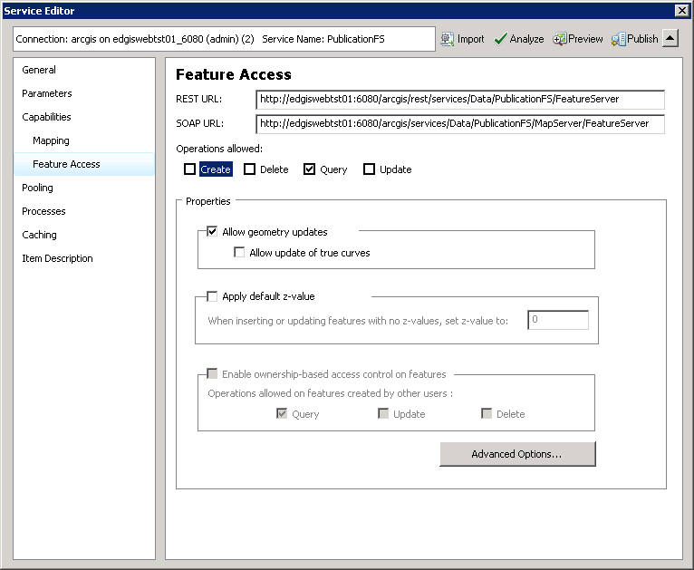
8. Click Analyze to ensure that the data is already registered on the server and no showstopper issues exist  
   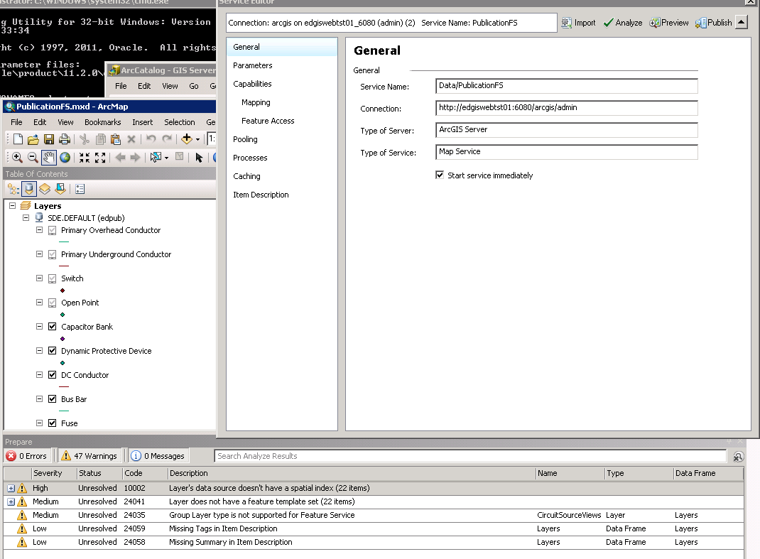
9. Click Publish

# Publish Printing Tools Service

## Registering the print templates folder with ArcGIS Server

The first think one needs to do is to register the folder where the templates will reside with ArcGIS Server. Here are the steps (the best way to accomplish this is to ask the system administrator to do it for you):

1. Start and login to ArcGIS Manager.
2. Click on ‘Site’



1. Click on ‘Data Store’

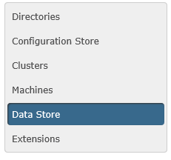

1. Click on ‘Register Folder’. Fill in the form and click ‘Create’.

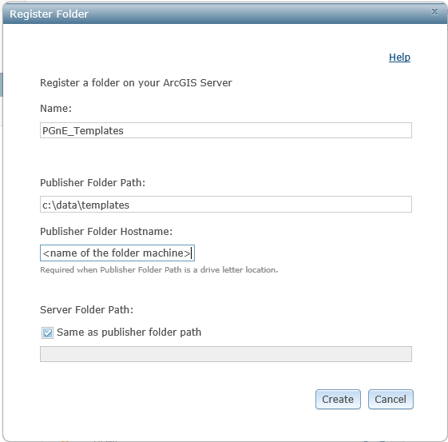

The folder is now registered with the server.

## Creating a Print Template in ArcMap

1. Open ArcMap
2. Click on ‘Stored Items’ and select ‘Page Templates’ tab.

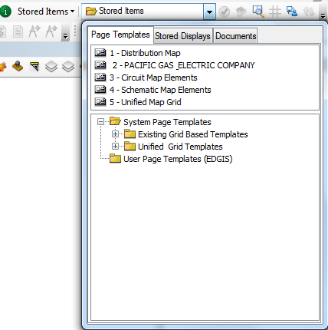

1. Select a page template which you want to use as a print template. For our example, you will select PACIFIC GAS ELECTRIC COMPANY.
2. Double click on the selected template.
3. Upon opening the template, ArcMap should be in the ‘Layout View’ mode. If not, you can select the layout view mode by clicking on the ‘Layout View’:



1. Move around the template (including zooming in and out) by using the Layout View toolbar:

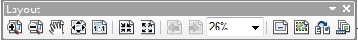

1. Save the template as an mxd document to the folder which you have registered with the server.
2. Remove any ArcFM Autotext and Dynamic Text elements from the template.
3. (Optional) – Add any text elements you need. Make sure to give each element a unique name:

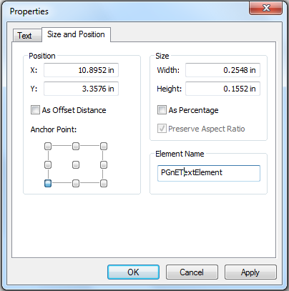

1. Re-save the document.
2. If the template has two data frames, bear in mind that server will write only to the active data frame. Therefore you have two options:
   1. Remove the non-active data frame from the document.
   2. Add layers to the non-active data frame. This way, that data frame can serve as an overview map. Here are the steps to configure the non-active data frame:
      1. Right click on the data frame and select ‘Properties’.
      2. Select the ‘Data Frame’ tab.
      3. Click on Extent drop down box and select ‘Other Data Frame’
      4. In ‘Derive extent from another data frame’s extent’ , select the data frame from which you want to derive extent.

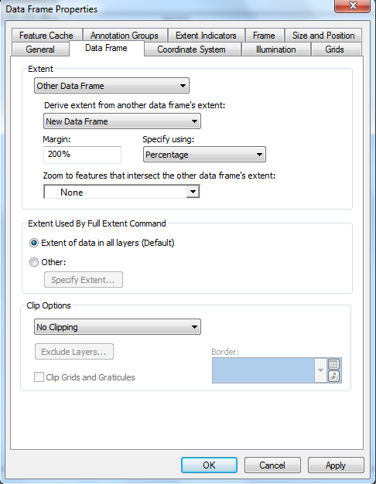

(Optional) Select ‘Extent indicators’ tab.

Select the data frame for which you want to see the extent indicator.

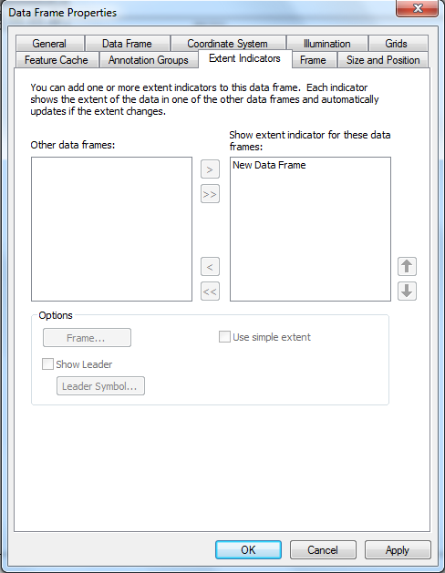

1. Re-save the document.

## Creating/Updating the ArcGIS Server Print Service

1. Click on Arc Toolbox

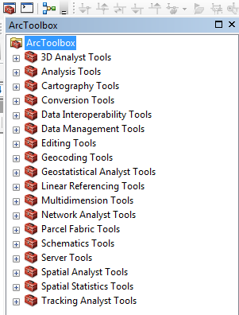

1. Expand Server Tools and Printing

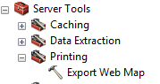

1. Double click on Export Web Map
2. Fill in the form.

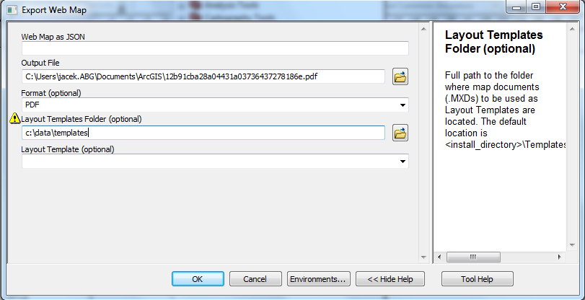

1. Click on OK.
2. Upon completing, the notification will come up in the lower right corner.

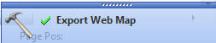

1. Click on Export Web Map.
2. The Results form will come up.

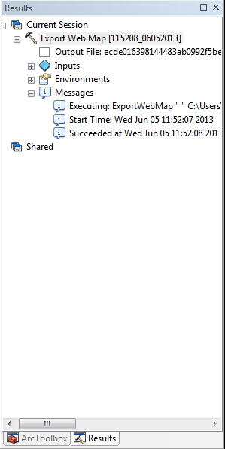

1. Right click on Export Web Map.
2. Select Share as/Geoprocessing Service

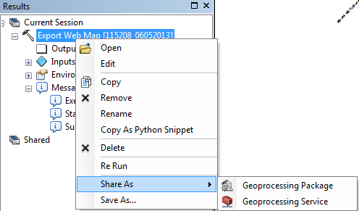

1. Select the appropriate option depending on whether you are creating a new service or overriding (updating) the existing one.

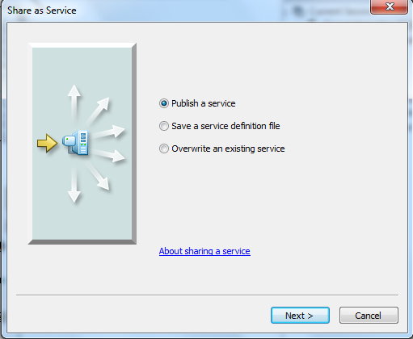

1. If you create a new service, select ‘Publish a Service’ and click Next.

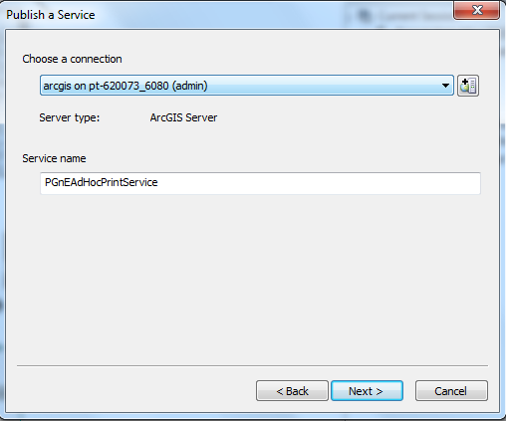

1. Choose the server to which you are publishing the service. Also, give the service an appropriate name.
2. Click Next
3. In the next screen, you can either click Continue or (optionally) create a new folder under which you will publish the print service.

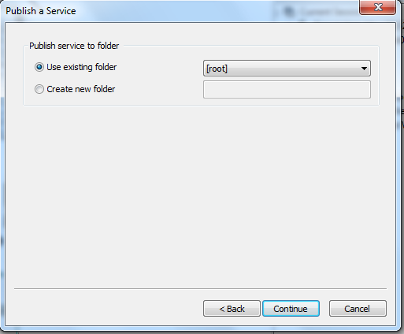

1. In the next screen, make sure to select Parameters option and then ensure that the service is being publish as asynchronous.

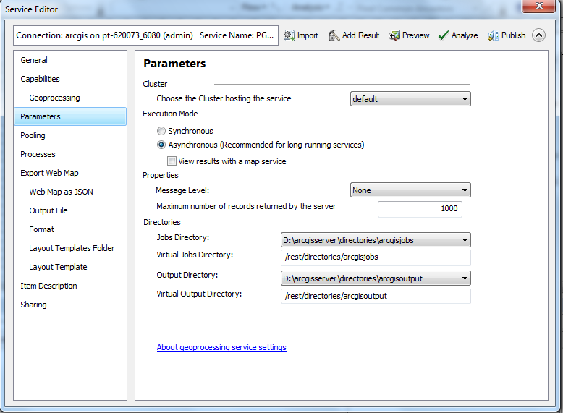

1. Click ‘Analyze’. Fix any errors and inspect for any unwanted warnings.
2. When all is OK – click ‘Publish’. Now you are ready to start using the service.
3. However, if you have decided to ‘Override an existing service’, then select the service to update from the following screen:

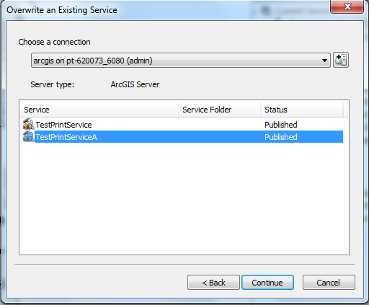

1. Click ‘Continue’, and you service should be updated. Now, you can use the newly added templates in the service.

## Creating/Updating the ArcGIS Server ExtractSend Service

1. Copy ExtractSend.tbx ($/EDAMGIS/Source_Development/WEBR/GPTools or release folder) locally
2. Click on the ExtractSend tool in the ExtractSend toolbox

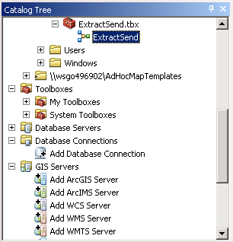

1. Right-click Edit   
     
   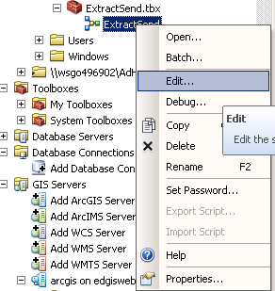
2. Right-click From > Open…  
     
   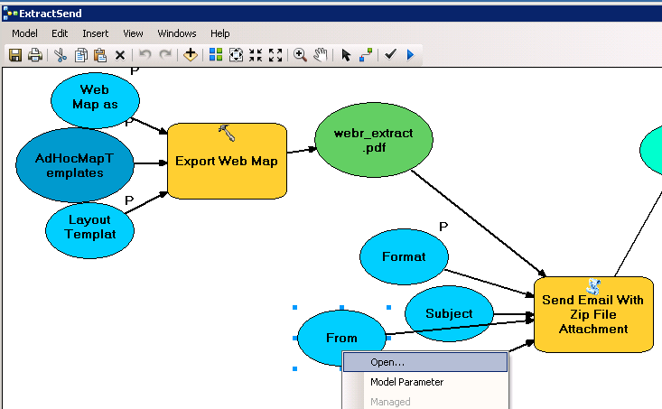
3. Ensure Value is appropriate i.e GISWEBRExportAdmin@pge.com  
     
   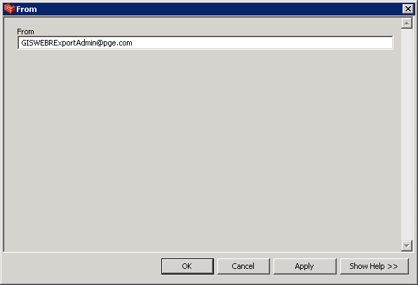
4. Select Export Web Map > Open  
   Ensure Output file folder exists e.g. C:\temp  
   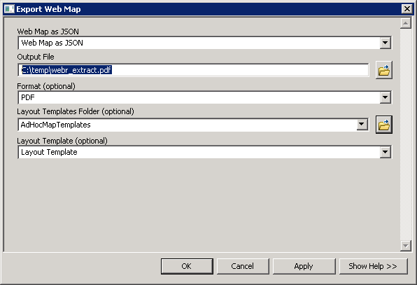
5. Click OK
6. Click OK and Save Model
7. Right-click Open the ExtractSend tool  
     
   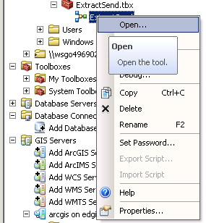
8. Ensure that the AdHocMapMapTemplates folder is set to the ArcGIS Server instance you are publishing to, and change the Format textbox to your PGE email address.  
     
   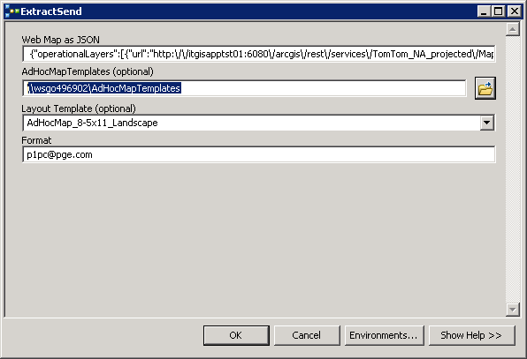
9. Copy the text from the Web Map as JSON textbox into Notepad
10. In Notepad Replace the URL hostnames as appropriate e.g. itgisapptst01:6080 -> wwwlbgis, wsgo496902:6080 -> edgiswebtrn01 (if for training environment)
11. Paste the Web Map as JSON string from Notepad, replacing what was there
12. Click OK
13. Run through the Publish Sequence as per previous Print Service, by running this tool and then Share As > GeoProcessing Service ensuring that you increase the “Maximum Time a client can use a service” to 6000. You will also have to have a Service Description as per Printing Service.  
      
    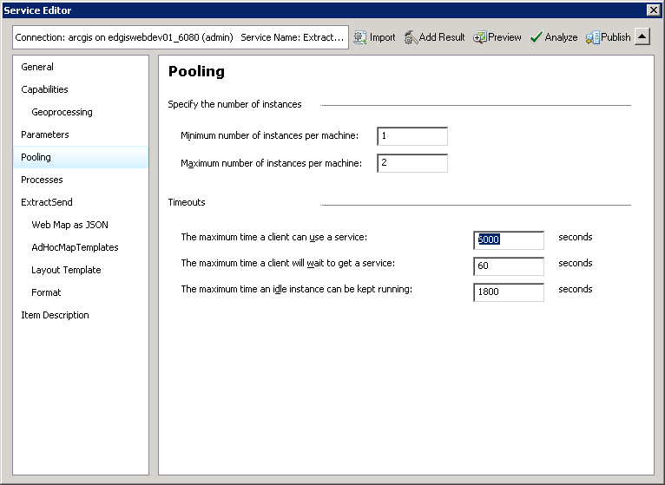
14. You will also have to ensure that the required Description fields are populated – they can be set to the name.  
      
    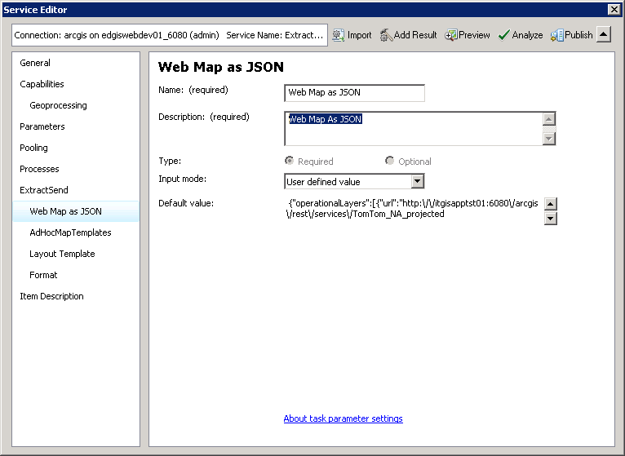
15. Publish Service
16. Ensure that none of the files in the AdhocMapTemplates folder are readonly
17. Test the Service by navigating to it in ArcCatalog, double click to open and OK. You should be emailed in a minute or two.

# Deploy Modified SendEmailWithZip.py script to Print Servers

1. On the Print Server farm, log into ArcGIS Manager in a browser
2. Go to Site > Directories
3. Click Add Directory  
   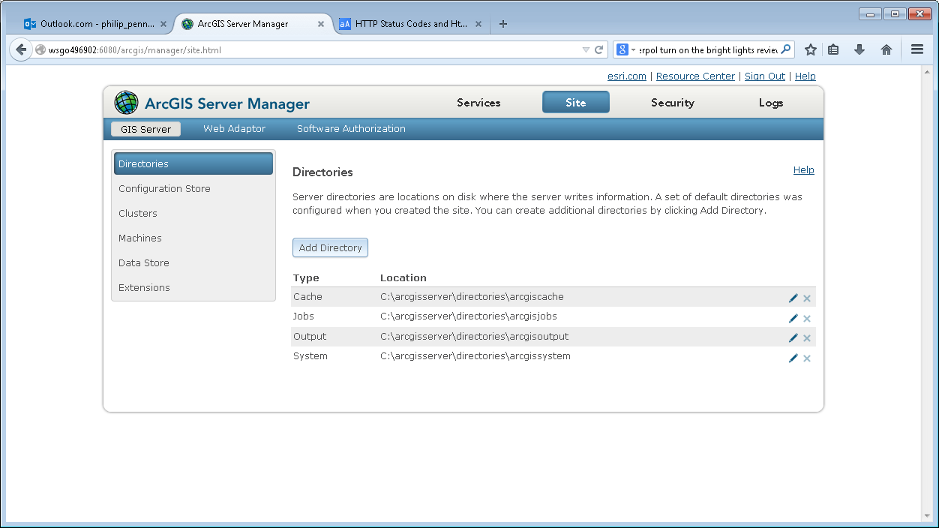
4. Add an Output Directory named PrintExtracts underneath the existing arcgisoutput directory. If the Print Server is in a cluster ensure that the Location is a UNC path (e.g. starts \\). Ensure Maximum file age is 4320  
   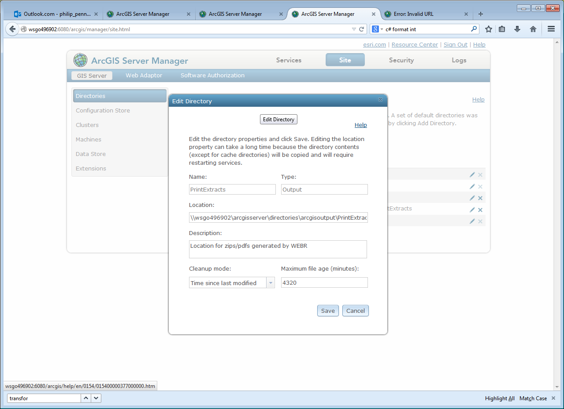   
   Click Add (or Save if you are editing existing)
5. Copy SendEmailWithZip.py from ($/EDAMGIS/Source_Development/WEBR/GPTools or release folder) locally
6. Edit the file locally
7. Modify the finalOutputDir value on line 9 to reflect the “Location” value from step (4). Ensure that the folder separators are double-slashes “\\”, with “\\\\” as the leading characters and “\\” at the end of the value (i.e. swap out wsgo496902 for your Print Server host name):  
   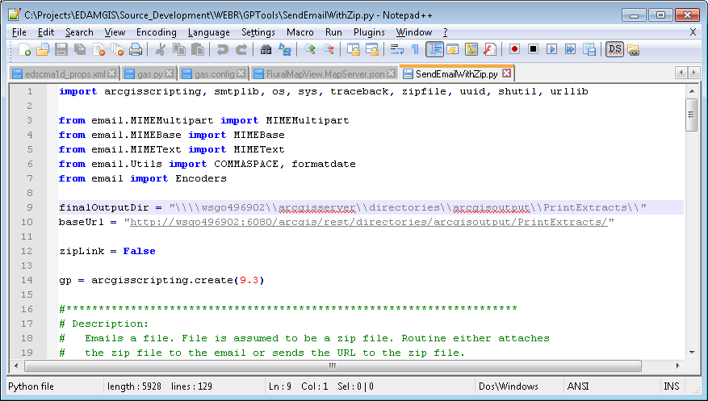
8. Modify the baseUrl value on line 9 to be the URL of your print server base. Note that for Training this would be replacing wsgo496902:6080/arcgis with edgiswebtrn01/arcgisPrintServer. For Production DC1 this would be replacing with edgiswwwprod1vip/arcgisPrintServer.  
   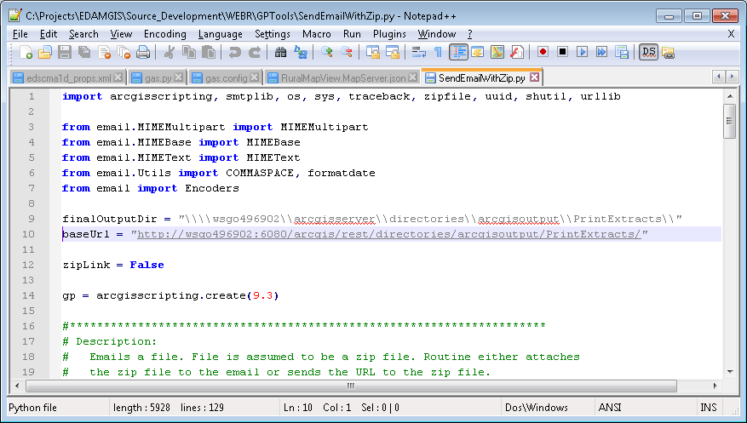
9. Repeat Steps 2-8 for each Print Server in the cluster e.g. edgisprtrn01/edgisprtrn02 etc.

# Convert ArcFM Stored Displays to MXDs

* + After you have created the data connections in ArcCatalog, move on to Opening the ArcFM Database Instance and the ArcFM Stored Displays.
  + Open ArcMap/ArcFM Desktop and sign in to the ArcFM Data instance of choice.
    - GIS ED data instance = EDGISP2T
    - Username/password = webr / webr
  + Open the ArcFM Stored Displayed to convert to an MXD.
    - Stored Displays to convert:
      * Circuit Map, Electric Distribution, Master, Schematic, Street Light.
      * These stored displays will need to be converted to individual map documents.
  + After Layers/Symbols complete drawing, From the ArcMap menu > go to File Save As.



* + The Save File Dialog appears. Select the location and name for the ArcMap Document and click Save.



* + After the save completes, close ArcMap. In a windows explorer, navigate to the location of the saved document and double click to re-open the document.



* + When the ArcFM Login screen comes up, **click Cancel** and then on the confirmation screen click “Yes”.

 

* + If any database login dialogs pop-up, click cancel.
  + Remove Redundant and unneeded layers and group layers:
    - Proposed Features
    - Substation
    - UFM
    - COTS
    - Maintenance Plat
  + After the Map Document loads, search for any missing layers or tables. (Look for any Red Exclamations next to a layer or table object in the table of contents)
  + Repair any broken data links.
  + Execute File > Save and close the document.

** Repeat the ArcFM Stored Display to MXD conversion for the following:

* Electric Distribution
* Circuit Map
* Streetlight
* Master
* Schematic
* Landbase

** Using the same process, Create MXDs from the following Groups/Layers:

* COTS
  + Open Circuit Map Stored Display.
  + Remove all Group Layer / Layers Except COTS Group Layer.
  + Remove All Table Objection from the MXD.
  + Save.
* Proposed Features
  + Open Circuit Map Stored Display.
  + Remove all Group Layer / Layers Except Proposed Features Group Layer.
  + Leave all Tables.
* Substation
  + Open Circuit Map Stored Display.
  + Remove all Group Layer / Layers Except Substation Group Layer.
  + Leave all Tables.

# Create a Landbase MXD with appropriate layers

Create a new MXD and Save as the Landbase_admin.mxd.

** Refer to PG&E ITGroup for appropriate layers and cartographic display of landbase layers. Below is an example configured by Schneider Electric due to the non-existence of any landbase layer designs at PG&E. The below example is not the appropriate layers or cartographic display. Landbase layer definition and cartography is ongoing and PG&E GIS is responsible for providing guidance with regards to this content. **

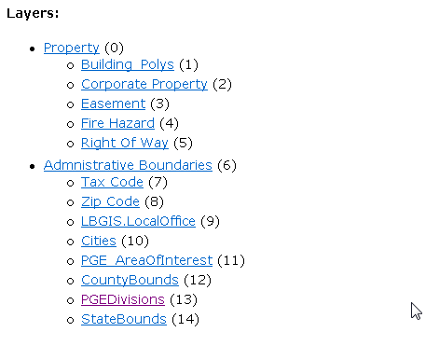

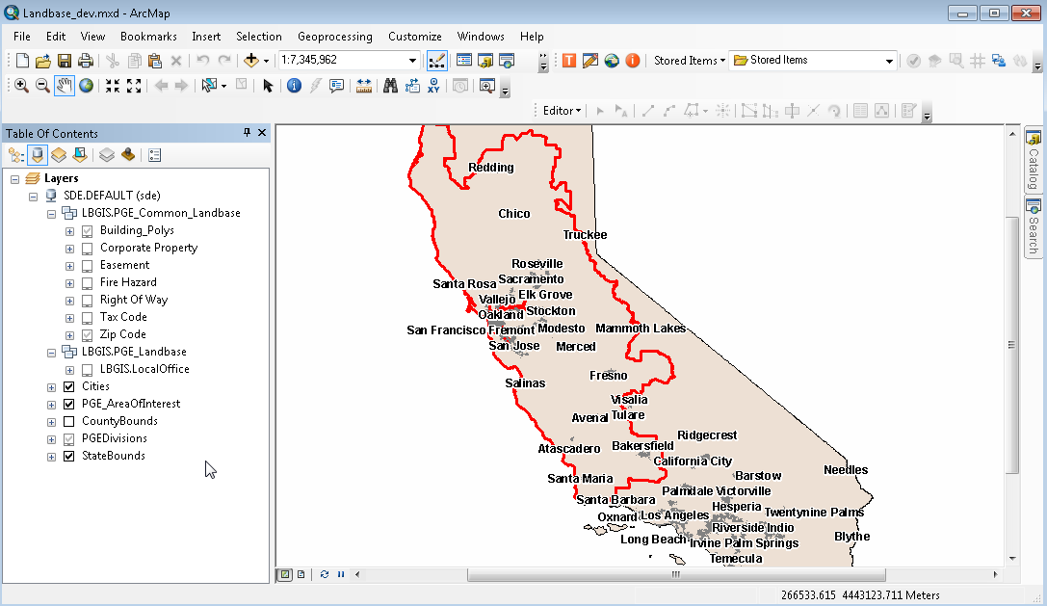

# Create a Geometry Service on the GIS Server

1. Create the Geometry Service.
   * In ArcCatalog, expand the Administrative GIS Server Connection node. From the available element click on the Utilities folder.

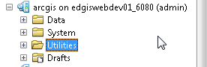

* + In the ArcCatalog Right side panel, right click on the node “Geometry” and click the Start from the menu.

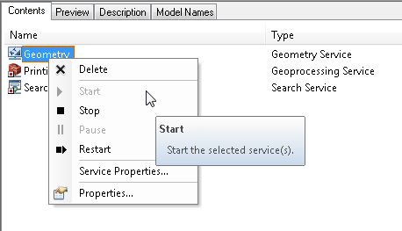

# Publish ArcGIS/ArcFM ED Map Services

1) Share a Map Document as a Map Service. Publish to an ArcGIS Server Map Service.

* + Before Stored Display designed layers and symbols are published for mass consumption through a map service, the web optimization process must be executed.
  + Open the Map Document to publish as a service.
  + All MXDs created in the previous steps need to be published as map services.
    - Electric Distribution
    - Circuit Map
    - ED Master
    - RuralMapView
    - Schematics
    - Substation
    - TLM



* + When ArcMap opens, do not sign into ArcFM.
  + After the document opens, Go To File > Share As > Select Share As Service.

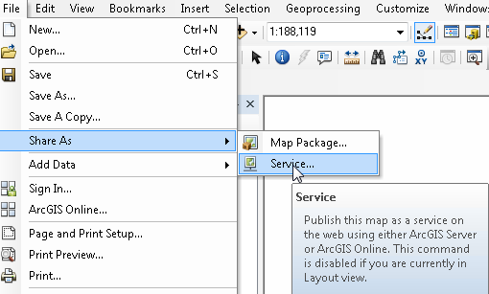

* + Select “Publish a Service” and click Next.



* + Select and ArcGIS Server Site to publish the resource to, enter the Map Service name and click Next.



* + Select the location on the ArcGIS Server Site to publish the map service. Either root folder or a sub folder. Click Continue.



* + The Service Editor will pop-up. Go To > Capabilities and:
    - uncheck KML capability.
    - enable ArcFMMapServer capability.



* + Click the “Parameters” tab  
    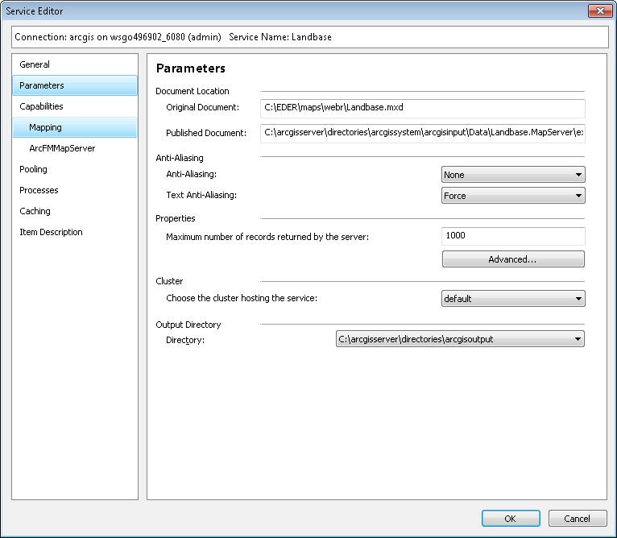
  + Click the Advanced… Button in Parameters  
    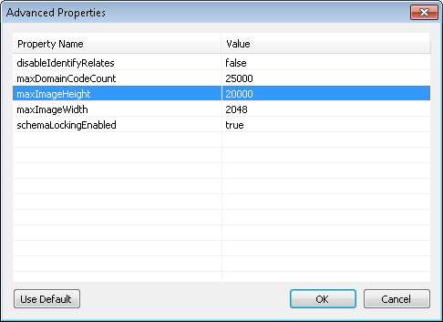
  + Ensure that maxImageHeight and maxImageWidth are set to 20000. Click OK.
  + Click “Analyze” in the top Right. ArcGIS will analyze the service to assure it is ready to publish. Review the Service Publishing Analyze results. **Be sure no Errors are listed in the results.**



* + In the Service Editor window, click Publish to create the map Service.



* + The Service Editor will process the request to publish the service. When its complete, click OK to the service creation complete message.



# Configure Resources with PG&E Silverlight ED Viewer

**\*\* Configuration step for all Web Servers \*\***

1. **Open a Windows Explorer on the server which ArcFM Silverlight is installed.**

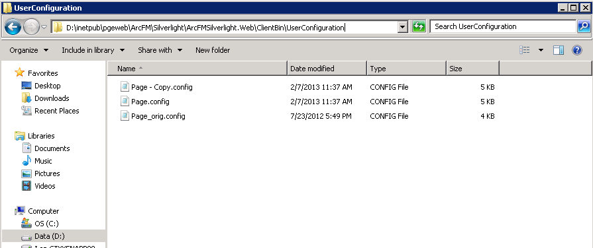

1. **Open the file “page.config” in notepad or other text editor. (MS Word should not be used).**

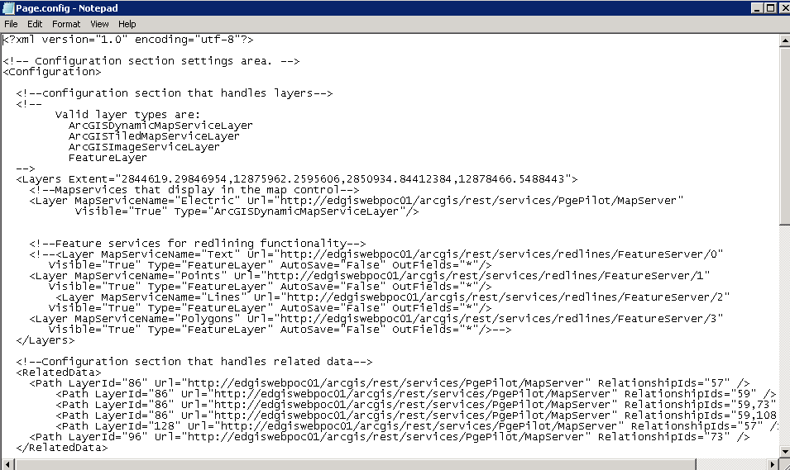

1. **Configure the Layers Element**



* Set the Layers Extent attribute to the following value:
  + -590488.852731593,12448442.280285,4349077.60807601,15066757.9287411

1. **Configure Layers section and Layer elements**

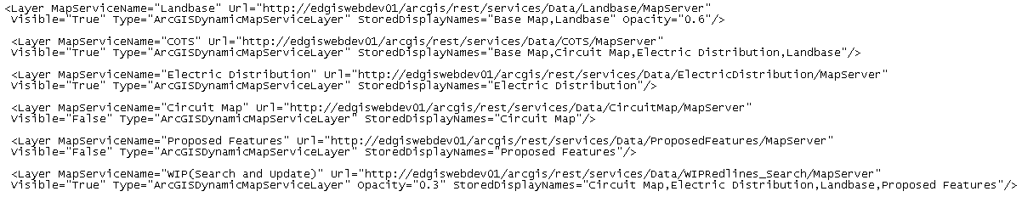

* Add Layer Elements for the following Map Services
  + COTS

<Layer MapServiceName="COTS"

Url=”http://{yourserver}/arcgis/rest/services/Data/COTS/MapServer”

Visible="True" Type="ArcGISDynamicMapServiceLayer"

StoredDisplayNames="Master View,Circuit Map View,Electric Distribution View,Landbase View, Schematics View, Streetlight View, Proposed Features View,Substations View"/>

* + Landbase Map Service.

<Layer MapServiceName="Landbase"

Url="http://{yourserver}/arcgis/rest/services/Data/Landbase/MapServer"

Visible="True" Type="ArcGISDynamicMapServiceLayer"

StoredDisplayNames=" Master View,Circuit Map View,Electric Distribution View,Landbase View, Schematics View, Streetlight View, Proposed Features View,Substations View "/>

* + Electric Distribution Map Service.

<Layer MapServiceName="Electric Distribution"

Url="http://{yourserver}/arcgis/rest/services/Data/ElectricDistribution/MapServer"

Visible="True" Type="ArcGISDynamicMapServiceLayer"

StoredDisplayNames="Electric Distribution View"/>

* + Circuit Map Service.

<Layer MapServiceName="Circuit Map"

Url="http://{yourserver}/arcgis/rest/services/Data/CircuitMap/MapServer"

Visible="False" Type="ArcGISDynamicMapServiceLayer"

StoredDisplayNames="Circuit Map View"/>

* + Master Map Service.

<Layer MapServiceName="Master"

Url="http://{yourserver}/arcgis/rest/services/Data/Master/MapServer"

Visible="False" Type="ArcGISDynamicMapServiceLayer"

StoredDisplayNames="Master View"/>

* + Schematic Map Service.

<Layer MapServiceName="Schematics"

Url="http://{yourserver}/arcgis/rest/services/Data/Schematic/MapServer"

Visible="False" Type="ArcGISDynamicMapServiceLayer"

StoredDisplayNames="Schematics View"/>

* + Streetlight Map Service.

<Layer MapServiceName="Streetlight"

Url="http://{yourserver}/arcgis/rest/services/Data/Streetlight/MapServer"

Visible="False" Type="ArcGISDynamicMapServiceLayer"

StoredDisplayNames="Streetlights View"/>

* + Proposed Features Map Service.

<Layer MapServiceName="Proposed Features"

Url="http://{yourserver}/arcgis/rest/services/Data/ProposedFeatures/MapServer"

Visible="False" Type="ArcGISDynamicMapServiceLayer"

StoredDisplayNames="Proposed Features View"/>

* + Substation Map Service.

<Layer MapServiceName="Substation Features"

Url="http://{yourserver}/arcgis/rest/services/Data/Substations/MapServer"

Visible="False" Type="ArcGISDynamicMapServiceLayer"

StoredDisplayNames="Substation View"/>

* + WIP Map Service with Feature Access.

<Layer MapServiceName="WIP(Search and Update)"

Url=http://{yourserver}/arcgis/rest/services/Data/WIPRedlines_Search/MapServer Visible="True" Type="ArcGISDynamicMapServiceLayer" Opacity="0.3" StoredDisplayNames="Circuit Map,Electric Distribution,Landbase,Proposed Features"/>

* + WIP Feature Edit Layer.

<Layer MapServiceName="WIP(Create)" Url="http://{yourserver}/arcgis/rest/services/Data/WIPRedlines_dev/FeatureServer/0"

Visible="True" Type="FeatureLayer" AutoSave="False" OutFields="*" Opacity="0.3" GroupFilter=”Everyone”/>

* + All Redline Feature Edit Layers.

<Layer MapServiceName="Text" Url=http://{yourserver}/arcgis/rest/services/Data/Redlines/FeatureServer/1

Visible="True" Type="FeatureLayer" AutoSave="False" OutFields="*"/>

<Layer MapServiceName="Points" Url="http://{yourserver/arcgis/rest/services/Data/Redlines/FeatureServer/0"

Visible="True" Type="FeatureLayer" AutoSave="False" OutFields="*"/>

<Layer MapServiceName="Lines" Url="http://{yourserver}/arcgis/rest/services/Data/Redlines/FeatureServer/2"

Visible="True" Type="FeatureLayer" AutoSave="False" OutFields="*"/>

<Layer MapServiceName="Polygons" Url="http://{yourserver}/arcgis/rest/services/Data/Redlines/FeatureServer/3"

Visible="True" Type="FeatureLayer" AutoSave="False" OutFields="*" Opacity="0.5" GroupFilter="Everyone"/>

* + Access the ArcGIS Server Site REST services explorer to gather URLs and service names to define each layer element. Example Below:

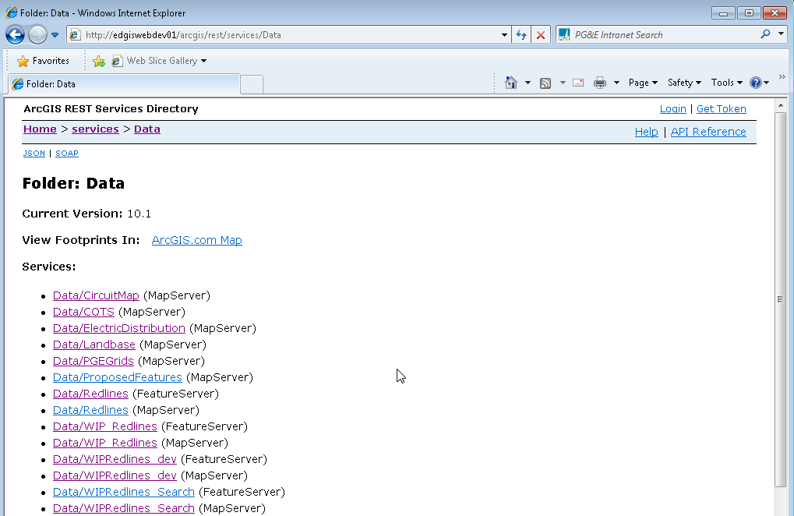

1. **Configure The Related Data Section.**

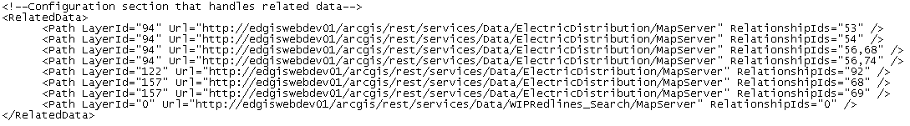

* Follow Instructions in the doc *WEB-R1_ConfiguringRelatedDataInArcFMSilverlight.doc* to learn how to create related data elements in the Silverlight Viewer. Or use the above example to create the relationships.
* Configure Related Data Elements for the following relationships:
  + Transformers to Service Point. (Single Tier Relationship)

<Path LayerId="94" Url="http://{yourserver}/arcgis/rest/services/Data/ElectricDistribution/MapServer" RelationshipIds="56" />

** Be sure to confirm all layerIds in the rest endpoints.

* + Transformers to Service Point to Service Location (Multi-Tier Relationship)

<Path LayerId="94" Url="http://{yourserver}/arcgis/rest/services/Data/ElectricDistribution/MapServer" RelationshipIds="56,68" />

** Be sure to confirm all layer IDs in the map service rest endpoints.

* + Secondary Generation to Service Point. (Single Tier Relationship)

<Path LayerId="106 Url="http://{yourserver}/arcgis/rest/services/Data/ElectricDistribution/MapServer" RelationshipIds="74" />

** Be sure to confirm all layer IDs in the map service rest endpoints.

1. **Configure the Search Elements**

Address Search

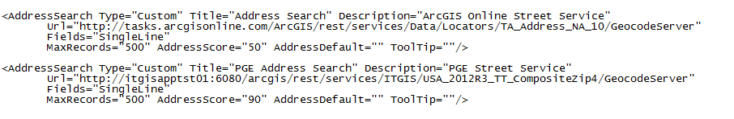

* Using the above example, Create the following Address Searches within the <Searches> section:
  + ArcGIS Online Street Address Search

<AddressSearch Type="Custom" Title="Address Search" Description="ArcGIS Online Street Service" Url="http://tasks.arcgisonline.com/ArcGIS/rest/services/Data/Locators/TA_Address_NA_10/GeocodeServer" Fields="SingleLine" MaxRecords="500" AddressScore="50" AddressDefault="" ToolTip=""/>

* + PGE Address Search

<AddressSearch Type="Custom" Title="PGE Address Search" Description="PGE Street Service" Url="http://itgisapptst01:6080/arcgis/rest/services/ITGIS/USA_2012R3_TT_CompositeZip4/GeocodeServer" Fields="SingleLine" MaxRecords="500" AddressScore="90" AddressDefault="" ToolTip=""/>

Standard Search



* Using the above example, Create the following Standard Search elements in the <Searches> section:
  + Operating Number Search.
    - Add a SearchLayer for all Electric Devices.
    - In Circuit Map Service, all elements in the Devices group layer.
    - Search Field = OperatingNumber
    - Go to the ArcGIS REST endpoint to confirm all LayerIDs for Electric Devices.

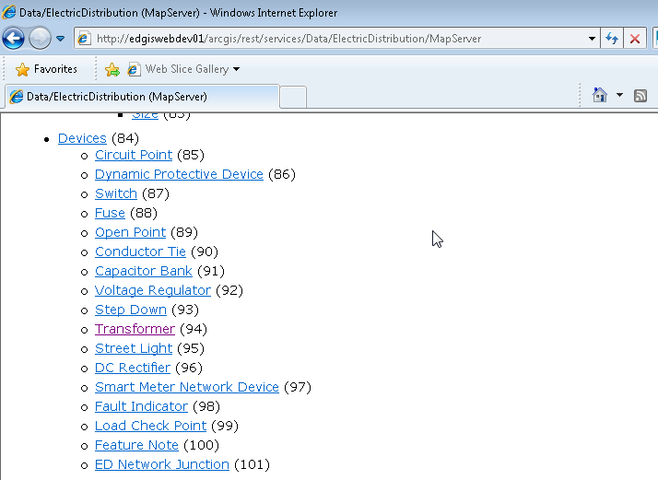

Example Below:

<Search Title="Operating Number" Description="Searches for Operating Number ( ex: 1082 )\r\nCircuit Point\r\nSwitch\r\nFuse\r\nOpen Point\r\nConductor Tile\r\nCapacitor Bank\r\nVoltage Regulator\r\nStep Down\r\nTransformer\r\nStreetlight\r\nDC Rectifier\r\nSmart Meter Network Device\r\nFault Indicator\r\nLoad Check Point">

<SearchLayer Url="http://{yourserver/arcgis/rest/services/Data/ElectricDistribution/MapServer" LayerId="85" Fields="OperatingNumber"/>

<SearchLayer Url="http://{yourserver/arcgis/rest/services/Data/ElectricDistribution/MapServer" LayerId="86" Fields="OperatingNumber"/>

<SearchLayer Url="http://{yourserver/arcgis/rest/services/Data/ElectricDistribution/MapServer" LayerId="87" Fields="OperatingNumber"/>

<SearchLayer Url="http://{yourserver/arcgis/rest/services/Data/ElectricDistribution/MapServer" LayerId="88" Fields="OperatingNumber"/>

<SearchLayer Url="http://{yourserver/arcgis/rest/services/Data/ElectricDistribution/MapServer" LayerId="89" Fields="OperatingNumber"/>

<SearchLayer Url="http://{yourserver/arcgis/rest/services/Data/ElectricDistribution/MapServer" LayerId="90" Fields="OperatingNumber"/>

<SearchLayer Url="http://{yourserver/arcgis/rest/services/Data/ElectricDistribution/MapServer" LayerId="91" Fields="OperatingNumber"/>

<SearchLayer Url="http://{yourserver/arcgis/rest/services/Data/ElectricDistribution/MapServer" LayerId="92" Fields="OperatingNumber"/>

<SearchLayer Url="http://{yourserver/arcgis/rest/services/Data/ElectricDistribution/MapServer" LayerId="93" Fields="OperatingNumber"/>

<SearchLayer Url="http://{yourserver/arcgis/rest/services/Data/ElectricDistribution/MapServer" LayerId="94" Fields="OperatingNumber"/>

<SearchLayer Url="http://{yourserver/arcgis/rest/services/Data/ElectricDistribution/MapServer" LayerId="95" Fields="OperatingNumber"/>

<SearchLayer Url="http://{yourserver/arcgis/rest/services/Data/ElectricDistribution/MapServer" LayerId="96" Fields="OperatingNumber"/>

<SearchLayer Url="http://{yourserver/arcgis/rest/services/Data/ElectricDistribution/MapServer" LayerId="97" Fields="OperatingNumber"/>

<SearchLayer Url="http://{yourserver}/arcgis/rest/services/Data/ElectricDistribution/MapServer" LayerId="98" Fields="OperatingNumber"/>

<SearchLayer Url="http://{yourserver}/arcgis/rest/services/Data/ElectricDistribution/MapServer" LayerId="99" Fields="OperatingNumber"/>

</Search>

* + Device ID Search
    - Add a SearchLayer for all Electric Devices.
    - In Circuit Map Service, all elements in the Devices group layer.
    - Search Field = CEDSADEVICEID
    - Go To the ArcGIS REST Service endpoint to confirm all layerIDs.



Example Below:

<Search Title="Device ID Search" Description="Searches for a Device ID ( ex: 1340035629 )\r\nCircuit Point\r\nSwitch\r\nFuse\r\nOpen Point\r\nConductor Tile\r\nCapacitor Bank\r\nVoltage Regulator\r\nStep Down\r\nTransformer\r\nStreetlight\r\nDC Rectifier\r\nSmart Meter Network Device\r\nFault Indicator\r\nLoad Check Point">

<SearchLayer Url="http://{yourserver}/arcgis/rest/services/Data/ElectricDistribution/MapServer" LayerId="85" Fields="CEDSADEVICEID"/>

<SearchLayer Url="http://{yourserver}/arcgis/rest/services/Data/ElectricDistribution/MapServer" LayerId="86" Fields="CEDSADEVICEID"/>

<SearchLayer Url="http://{yourserver}/arcgis/rest/services/Data/ElectricDistribution/MapServer" LayerId="87" Fields="CEDSADEVICEID"/>

<SearchLayer Url="http://{yourserver}/arcgis/rest/services/Data/ElectricDistribution/MapServer" LayerId="88" Fields="CEDSADEVICEID"/>

<SearchLayer Url="http://{yourserver}/arcgis/rest/services/Data/ElectricDistribution/MapServer" LayerId="89" Fields="CEDSADEVICEID"/>

<SearchLayer Url="http://{yourserver}/arcgis/rest/services/Data/ElectricDistribution/MapServer" LayerId="90" Fields="CEDSADEVICEID"/>

<SearchLayer Url="http://{yourserver}/arcgis/rest/services/Data/ElectricDistribution/MapServer" LayerId="91" Fields="CEDSADEVICEID"/>

<SearchLayer Url="http://{yourserver}/arcgis/rest/services/Data/ElectricDistribution/MapServer" LayerId="92" Fields="CEDSADEVICEID"/>

<SearchLayer Url="http://{yourserver}/arcgis/rest/services/Data/ElectricDistribution/MapServer" LayerId="93" Fields="CEDSADEVICEID"/>

<SearchLayer Url="http://{yourserver}/arcgis/rest/services/Data/ElectricDistribution/MapServer" LayerId="94" Fields="CEDSADEVICEID"/>

<SearchLayer Url="http://{yourserver}/arcgis/rest/services/Data/ElectricDistribution/MapServer" LayerId="95" Fields="CEDSADEVICEID"/>

<SearchLayer Url="http://{yourserver}/arcgis/rest/services/Data/ElectricDistribution/MapServer" LayerId="96" Fields="CEDSADEVICEID"/>

<SearchLayer Url="http://{yourserver}/arcgis/rest/services/Data/ElectricDistribution/MapServer" LayerId="97" Fields="CEDSADEVICEID"/>

<SearchLayer Url="http://{yourserver}/arcgis/rest/services/Data/ElectricDistribution/MapServer" LayerId="98" Fields="CEDSADEVICEID"/>

<SearchLayer Url="http://{yourserver}/arcgis/rest/services/Data/ElectricDistribution/MapServer" LayerId="99" Fields="CEDSADEVICEID"/>

</Search>

* + Line ID Search
    - All Conductors.
    - In Circuit Map Service, all elements in the Conductors group layer.
    - Search Field = CEDSADEVICEID
    - Go To the ArcGIS REST Service endpoint to confirm all layerIDs.

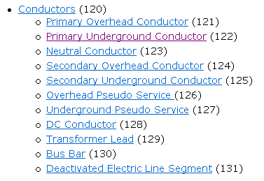

Example Below:

<Search Type="Custom" Title="Line ID Search" Description="Search for a Conductor By ID ( ex: 3546628 )">

<SearchLayer Url="http://{yourserver}/arcgis/rest/services/Data/ElectricDistribution/MapServer" LayerId="121" Fields="CEDSADEVICEID"/>

<SearchLayer Url="http://{yourserver}/arcgis/rest/services/Data/ElectricDistribution/MapServer" LayerId="122" Fields="CEDSADEVICEID"/>

<SearchLayer Url="http://{yourserver}/arcgis/rest/services/Data/ElectricDistribution/MapServer" LayerId="123" Fields="CEDSADEVICEID"/>

<SearchLayer Url="http://{yourserver}/arcgis/rest/services/Data/ElectricDistribution/MapServer" LayerId="124" Fields="CEDSADEVICEID"/>

<SearchLayer Url="http://{yourserver}/arcgis/rest/services/Data/ElectricDistribution/MapServer" LayerId="125" Fields="CEDSADEVICEID"/>

<SearchLayer Url="http://{yourserver}/arcgis/rest/services/Data/ElectricDistribution/MapServer" LayerId="126" Fields="CEDSADEVICEID"/>

<SearchLayer Url="http://{yourserver}/arcgis/rest/services/Data/ElectricDistribution/MapServer" LayerId="127" Fields="CEDSADEVICEID"/>

<SearchLayer Url="http://{yourserver}/arcgis/rest/services/Data/ElectricDistribution/MapServer" LayerId="127" Fields="CEDSADEVICEID"/>

<SearchLayer Url="http://{yourserver}/arcgis/rest/services/Data/ElectricDistribution/MapServer" LayerId="128" Fields="CEDSADEVICEID"/>

<SearchLayer Url="http://{yourserver}/arcgis/rest/services/Data/ElectricDistribution/MapServer" LayerId="129" Fields="CEDSADEVICEID"/>

<SearchLayer Url="http://{yourserver}/arcgis/rest/services/Data/ElectricDistribution/MapServer" LayerId="130" Fields="CEDSADEVICEID"/>

</Search>

* + Feeder Search
    - All Conductors and All Devices.
    - In Circuit Map Service, all elements in the Conductors and Device group layer.
    - Search Field = CIRCUITID
    - Go To the ArcGIS REST Service endpoint to confirm all layerIDs.



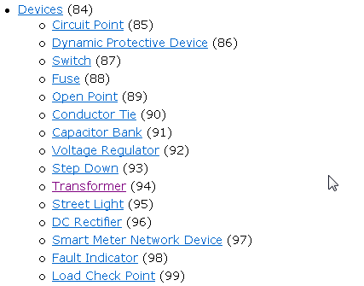

Example Below:

<Search Type="Custom" Title="Feeder Search" Description="Searches for Circuit ID value on Circuit Features ( ex: 254572107 )">

<SearchLayer Url="http://{yourserver}/arcgis/rest/services/Data/ElectricDistribution/MapServer" LayerId="85" Fields="CIRCUITID"/>

<SearchLayer Url="http://{yourserver}/arcgis/rest/services/Data/ElectricDistribution/MapServer" LayerId="86" Fields="CIRCUITID"/>

<SearchLayer Url="http://{yourserver}/arcgis/rest/services/Data/ElectricDistribution/MapServer" LayerId="87" Fields="CIRCUITID"/>

<SearchLayer Url="http://{yourserver}/arcgis/rest/services/Data/ElectricDistribution/MapServer" LayerId="88" Fields="CIRCUITID"/>

<SearchLayer Url="http://{yourserver}/arcgis/rest/services/Data/ElectricDistribution/MapServer" LayerId="89" Fields="CIRCUITID"/>

<SearchLayer Url="http://{yourserver}/arcgis/rest/services/Data/ElectricDistribution/MapServer" LayerId="90" Fields="CIRCUITID"/>

<SearchLayer Url="http://{yourserver}/arcgis/rest/services/Data/ElectricDistribution/MapServer" LayerId="91" Fields="CIRCUITID"/>

<SearchLayer Url="http://{yourserver}/arcgis/rest/services/Data/ElectricDistribution/MapServer" LayerId="92" Fields="CIRCUITID"/>

<SearchLayer Url="http://{yourserver}/arcgis/rest/services/Data/ElectricDistribution/MapServer" LayerId="93" Fields="CIRCUITID"/>

<SearchLayer Url="http://{yourserver}/arcgis/rest/services/Data/ElectricDistribution/MapServer" LayerId="94" Fields="CIRCUITID"/>

<SearchLayer Url="http://{yourserver}/arcgis/rest/services/Data/ElectricDistribution/MapServer" LayerId="95" Fields="CIRCUITID"/>

<SearchLayer Url="http://{yourserver}/arcgis/rest/services/Data/ElectricDistribution/MapServer" LayerId="96" Fields="CIRCUITID"/>

<SearchLayer Url="http://{yourserver}/arcgis/rest/services/Data/ElectricDistribution/MapServer" LayerId="97" Fields="CIRCUITID"/>

<SearchLayer Url="http://{yourserver}/arcgis/rest/services/Data/ElectricDistribution/MapServer" LayerId="98" Fields="CIRCUITID"/>

<SearchLayer Url="http://{yourserver}/arcgis/rest/services/Data/ElectricDistribution/MapServer" LayerId="99" Fields="CIRCUITID"/>

<SearchLayer Url="http://{yourserver}/arcgis/rest/services/Data/ElectricDistribution/MapServer" LayerId="103" Fields="CIRCUITID"/>

<SearchLayer Url="http://{yourserver}/arcgis/rest/services/Data/ElectricDistribution/MapServer" LayerId="121" Fields="CIRCUITID"/>

<SearchLayer Url="http://{yourserver}/arcgis/rest/services/Data/ElectricDistribution/MapServer" LayerId="122" Fields="CIRCUITID"/>

<SearchLayer Url="http://{yourserver}/arcgis/rest/services/Data/ElectricDistribution/MapServer" LayerId="123" Fields="CIRCUITID"/>

<SearchLayer Url="http://{yourserver}/arcgis/rest/services/Data/ElectricDistribution/MapServer" LayerId="124" Fields="CIRCUITID"/>

<SearchLayer Url="http://{yourserver}/arcgis/rest/services/Data/ElectricDistribution/MapServer" LayerId="125" Fields="CIRCUITID"/>

<SearchLayer Url="http://{yourserver}/arcgis/rest/services/Data/ElectricDistribution/MapServer" LayerId="126" Fields="CIRCUITID"/>

<SearchLayer Url="http://{yourserver}/arcgis/rest/services/Data/ElectricDistribution/MapServer" LayerId="127" Fields="CIRCUITID"/>

<SearchLayer Url="http://{yourserver}/arcgis/rest/services/Data/ElectricDistribution/MapServer" LayerId="127" Fields="CIRCUITID"/>

<SearchLayer Url="http://{yourserver}/arcgis/rest/services/Data/ElectricDistribution/MapServer" LayerId="128" Fields="CIRCUITID"/>

<SearchLayer Url="http://{yourserver}/arcgis/rest/services/Data/ElectricDistribution/MapServer" LayerId="129" Fields="CIRCUITID"/>

<SearchLayer Url="http://{yourserver}/arcgis/rest/services/Data/ElectricDistribution/MapServer" LayerId="130" Fields="CIRCUITID"/>

</Search>

* + Map Number Search

Example Below:

<Search Type="Custom" Title="Map Number Search" Description="Search for a Map Number ( ex: 2926236 )">

<SearchLayer Url="http://{yourserver}/arcgis/rest/services/Data/{yourservice}/MapServer" LayerId="0" Fields="MAPNUMBER"/>

</Search>

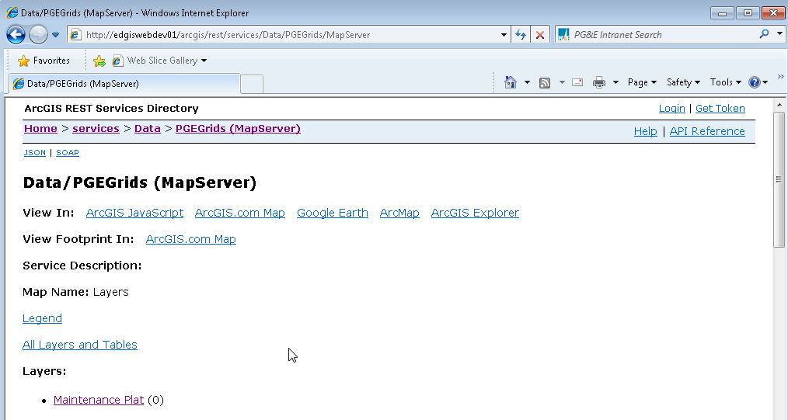

Search Service



* Using the above example, Create the following Service Searches in the <Searches> section:
  + CGC Number Search:
    - Search all layers that have a CGC12 field in the Circuit Map Service.
    - LayerIds= {rest index value in the circuit map service for all layers containing CGC12}
    - Search Field = CGC12

Example Below:

<Search Type="Custom" Title="CGC Number Search" Description="Search for Electric Equipment by CGC Number ( ex: 419098944102)">

<SearchService Url="http://edgiswebdev01/arcgis/rest/services/Data/ElectricDistribution/MapServer" LayerIds="103,104,108,157" Fields="CGC12"/>

</Search>

Search non-ArcFM Feature Layer or Search Table Layer



* + Service Point ID Search
    - In Circuit Map Service, locate the ServicePoint Table Layer.
    - Use its index value to create the search.
    - Search Field = SERVICEPOINTID
    - LayerType=”Table”

Example Below:

Search Type="Custom" Title="Service Point Search" Description="Search for a ServicePoint ID ( ex: 7893670605 )">

<SearchTable Url="http://{yourserver}/arcgis/rest/services/Data/ElectricDistribution/MapServer" ID="157" Fields="SERVICEPOINTID" LayerType="Table"/>

</Search>

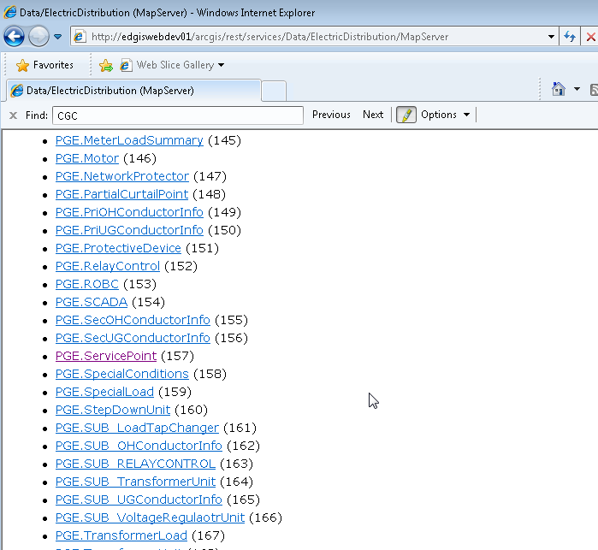

1. **Configure the Editor Elements**



* *EditorLayer Element*
  + PointServiceName=“{Name of Map Service Layer defined in the <Layers> section that will be used as Redline Point Feature Layer}”
  + PolylineServiceName=“{Name of Map Service Layer defined in the <Layers> section that will be used as Redline Line Feature Layer}”
  + PolygonServiceName=“{Name of Map Service Layer defined in the <Layers> section that will be used as Redline Line Feature Layer}”,“{Name of Map Service Layer defined in the <Layers> section that will be used as WIP Cloud Feature Layer}”,
  + TextServiceName=”{Name of Map Service Layer defined in the <Layers> section that will be used as Text Redline Feature Layer}”
  + PolygonShapes=””
  + PointSymbolReference=”1”

<!--Configuration section for redlining -->

<Editor>

<EditorLayer PointServiceName="Points" PolylineServiceName="Lines" PolygonServiceName="Polygons,WIP(Create)" TextServiceName="Text" />

<PolygonShape Shapes="" />

<!-- The base reference for scaling redline text and points as well as selection markers -->

<PointSymbol ReferenceResolution="1" />

</Editor>

1. **Configuring Tracing Elements**

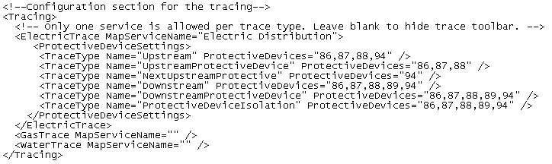

* *ElectricTrace Element*
  + MapServiceName=“{Name of Map Service Layer defined in the <Layers> section that will be used as the tracing service}”
* *ProtectiveDeviceSettings Element*
  + Contains a definition of enabled protective devices by trace type.
* *TraceType Elements*
  + Name=”{Name of the Trace to apply custom enabling of protective devices}”
  + ProtectiveDevices=”{Layer IDs from the Electric Trace Service for the protective devices that should be enabled for each trace type}”
    - **By Default, enable all protective devices.**
    - **Go To ArcFM REST Endpoint of the Electric Trace Service to confirm all configured protective device layers in the DB.**
    - [**http://edgiswebdev01/arcgis/rest/services/Data/ElectricDistribution/MapServer/exts/ArcFMMapServer**](http://edgiswebdev01/arcgis/rest/services/Data/ElectricDistribution/MapServer/exts/ArcFMMapServer)

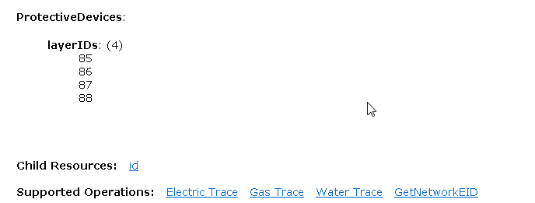

* *GasTrace Element*
  + MapServiceName=“”
* *WaterTrace Element*
  + MapServiceName=“”

Example Below:

<!--Configuration section for the tracing-->

<Tracing>

<!-- Only one service is allowed per trace type. Leave blank to hide trace toolbar. -->

<ElectricTrace MapServiceName="{your electric tracing service name}">

<ProtectiveDeviceSettings>

<TraceType Name="Upstream" ProtectiveDevices="86,87,88,94" />

<TraceType Name="UpstreamProtectiveDevice" ProtectiveDevices="86,87,88,94/>

<TraceType Name="NextUpstreamProtective" ProtectiveDevices="86,87,88,94" />

<TraceType Name="Downstream" ProtectiveDevices="86,87,88,89,94" />

<TraceType Name="DownstreamProtectiveDevice" ProtectiveDevices="86,87,88,89,94" />

<TraceType Name="ProtectiveDeviceIsolation" ProtectiveDevices="86,87,88,89,94" />

</ProtectiveDeviceSettings>

</ElectricTrace>

<GasTrace MapServiceName="" />

<WaterTrace MapServiceName="" />

</Tracing>

1. **Configure Attribute Viewer Settings**

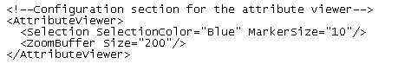

* *Selection Element*
  + SelectionColor=“Blue”.
  + MarkerSize=“10”.
* *ZoomBuffer Element*
  + Size=“200”

Example Below:

<!--Configuration section for the attribute viewer-->

<AttributeViewer>

<Selection SelectionColor="Blue" MarkerSize="10"/>

<ZoomBuffer Size="200"/>

</AttributeViewer>

1. **Configure the Tools Section**



* *Measure Element*
  + ProjectionWKID=“32611”.
* *GeometryService Element*
  + Set the Url Attribute: Url=http://{yourserver}/arcgis/rest/services/utilities/Geometry/GeometryServer

Example Below:

<!--Configuration section for the tools. Used for the measure tool and the coordinate tool. -->

<Tools>

<Measure ProjectionWKID="32611" />

<GeometryService Url="http://{yourserver}/arcgis/rest/services/Utilities/Geometry/GeometryServer" />

</Tools>

1. **Configure AD Groups that can submit WIP Edits.**



* *EditDB Element*
  + GroupFilter=“{name of DB group that all Estimators and Mappers belong to}”.

Example Below:

<EditDB GroupFilter="Everyone"/>

1. **Configure Layer Visibility Settings**



* *ClientSideVisibility Element*
  + Visible=“True”
  + ScaleRange=”True”

Example Below:

<LayerVisibility>

<ClientSideVisibility Visible="True" ScaleRange="True" />

</LayerVisibility>

1. **Configure Log Settings**



* *Target Element*
  + Type=”File”
  + FileName=”Miner.Silverlight.Client”
  + MaxArchiveFiles=”2”
  + ArchiveAboveSize=”102400”
  + LogLevel=”Info”
* *Target Element*
  + Type=”Service”
  + Service=”Services/nLogReceiverService.asmx/LogMessage”
  + LogLevel=”Warn”

Example Below:

<!--Configuration section for client side logging -->

<Logging>

<target Type="File" FileName="Miner.Silverlight.Client" MaxArchiveFiles="2" ArchiveAboveSize="102400" LogLevel="Info" />

<target Type="Service" Service="Services/nLogReceiverService.asmx/LogMessage" LogLevel="Warn" />

</Logging>

1. **Configure the Geographic Filter Control**

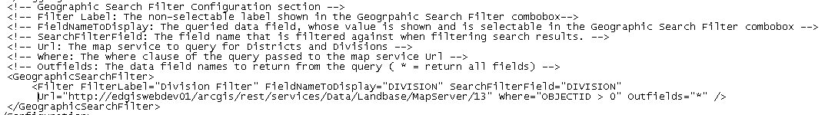

* *Filter Element*
  + FilterLabel=“{Name of the Filter the user will see}”
  + FieldNameToDisplay=”{Values of this field will be displayed to the user}”
  + SearchFilterField=”{Name of the Field to apply the filter value to}”
  + Url=”{Url to the map service layer containing the Division or District Filter features}”
  + Where=”{Where Clause to determine what features will be used as geographic filters}”
  + Outfields=”*”

Example Below:

<!-- SearchFilterField: The field name that is filtered against when filtering search results. -->

<!-- Url: The map service to query for Districts and Divisions -->

<!-- Where: The where clause of the query passed to the map service Url -->

<!-- Outfields: The data field names to return from the query ( * = return all fields) -->

<GeographicSearchFilter>

<Filter FilterLabel="Division Filter" FieldNameToDisplay="DIVISION" SearchFilterField="DIVISION"

Url="http://edgiswebdev01/arcgis/rest/services/Data/Landbase/MapServer/13" Where="OBJECTID > 0"

Outfields="*" />

</GeographicSearchFilter>

1. **Configure the Help Links**

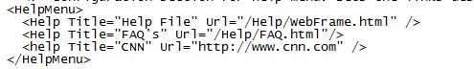

* *Help Element*
  + Title=”{Name of custom help link to be provided by PG&E IT – Nadeem}”
  + Url=”{Url of custom help link to be provided by PG&E IT – Nadeem}”

Example Below:

<!--Configuration section for Help menu. Sets the links desired for the help menu system -->

<HelpMenu>

<Help Title="Help File" Url="/Help/WebFrame.html" />

<Help Title="FAQ's" Url="/Help/FAQ.html"/>

<help Title="CNN" Url="http://www.cnn.com" />

</HelpMenu>

1. Save and close the page.config

# Configure the Templates Configuration File

**\*\* Configuration step for all Web Servers \*\***

1. **Open a Windows Explorer on the server which ArcFM Silverlight is installed.**



1. **Navigate to the [ED Viewer Install Dir]\ClientBin\Templates directory and Open the file “Templates.config” in notepad or other text editor. (MS Word should not be used).**

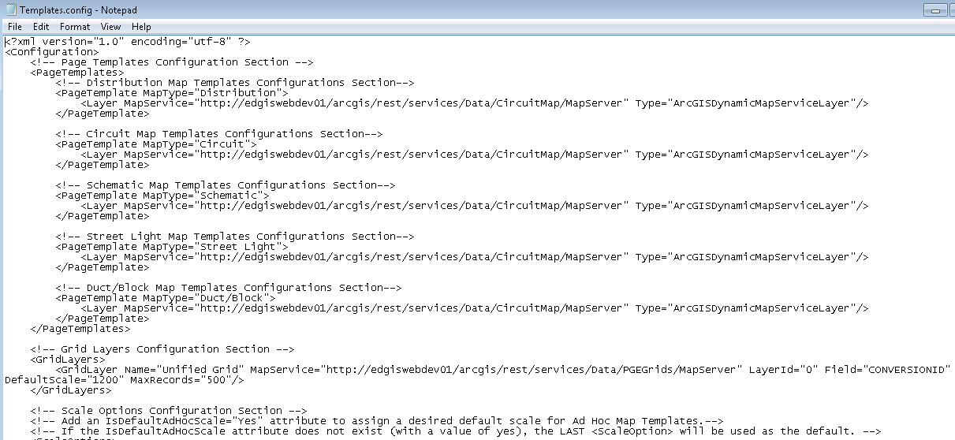

1. **Configure the PageTemplate Elements**



In the <PageTemplates> section, add PageTemplate elements for all of the following:

* Configure the Distribution Map Type:
  + Example Below:

<PageTemplate MapType="Distribution">

<Layer MapService="http://{yourserver}/arcgis/rest/services/Data/ElectricDistribution/MapServer"

Type="ArcGISDynamicMapServiceLayer"/>

</PageTemplate>

* Configure the Circuit Map Type:
  + Example Below:

<PageTemplate MapType="Circuit">

<Layer MapService="http://{yourserver}/arcgis/rest/services/Data/CircuitMap/MapServer"

Type="ArcGISDynamicMapServiceLayer"/>

</PageTemplate>

* Configure the Block Map Type:
  + Example Below:

<PageTemplate MapType="Duct/Block">

<Layer MapService="http://{yourserver}/arcgis/rest/services/Data/BlockMap/MapServer"

Type="ArcGISDynamicMapServiceLayer"/>

</PageTemplate>

* Configure the Streetlight Map Type:
  + Example Below:

<PageTemplate MapType="Distribution">

<Layer MapService="http://{yourserver}/arcgis/rest/services/Data/Streetlight/MapServer"

Type="ArcGISDynamicMapServiceLayer"/>

</PageTemplate>

* Configure the Schematic Map Type:
  + Example Below:

<PageTemplate MapType="Distribution">

<Layer MapService="http://{yourserver}/arcgis/rest/services/Data/Schematic/MapServer"

Type="ArcGISDynamicMapServiceLayer"/>

</PageTemplate>

* Configure the Master Map Type:

1. **Configure the Grid Layer Section**



* Add the map service endpoints, layer ID, Field, Default Scale and MaxRecords for each Grid Layer to be used in printing process.
  + Configure the Unified Grid:

<!-- Grid Layers Configuration Section -->

**<GridLayers>**

<GridLayer Name="Unified Grid" MapService="http://{yourserver}/arcgis/rest/services/Data/PGEGrids/MapServer"

LayerId="0" Field="CONVERSIONID" DefaultScale="1200" MaxRecords="500"/>

**</GridLayers>**

**\*\*\*\* The CONVERSIONID field is being used in the place of the MapNumber field. MapNumber Field is the designed field to use. However, current data instance all MapNumber attributes are NULL and can’t be used to drive the printing process.**

* + Add additional GridLayer elements as needed.

1. **Configure the Scale Options Section**

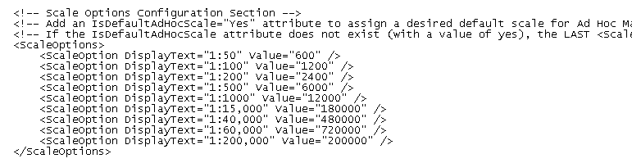

* Configure the display Text and map scale value for each scale option a user would see.

**22. Save and Close the Templates.Config file.**